use advanced function to calculate %. Below, I choose Advanced Function on the field I want to display as %
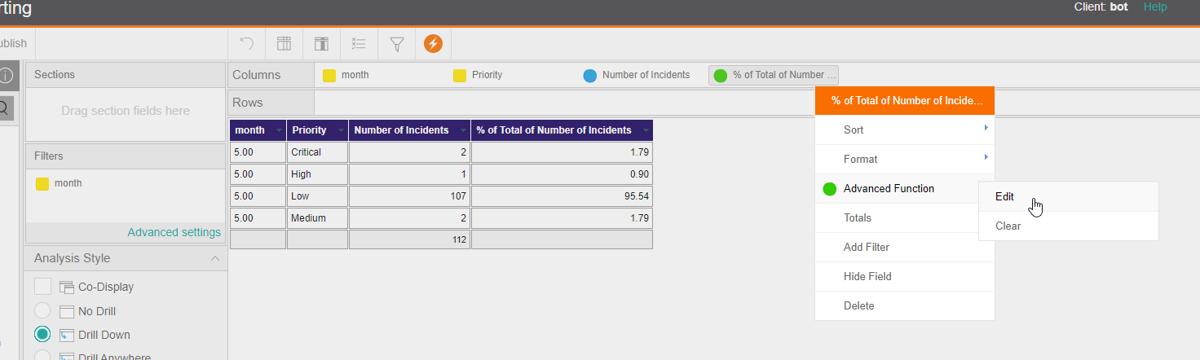
Choose Percentage of Total
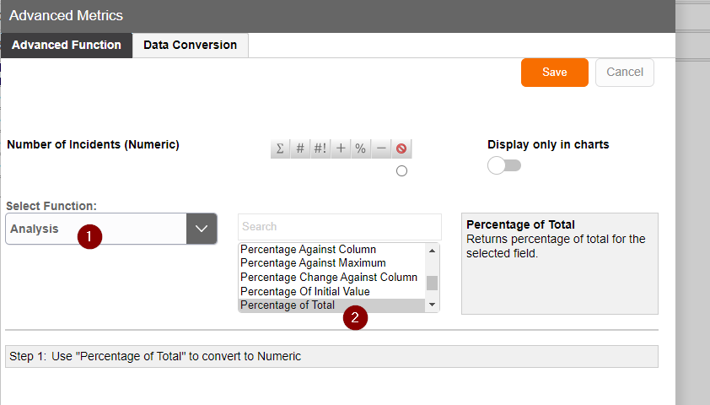
Field now show like this showing the % value
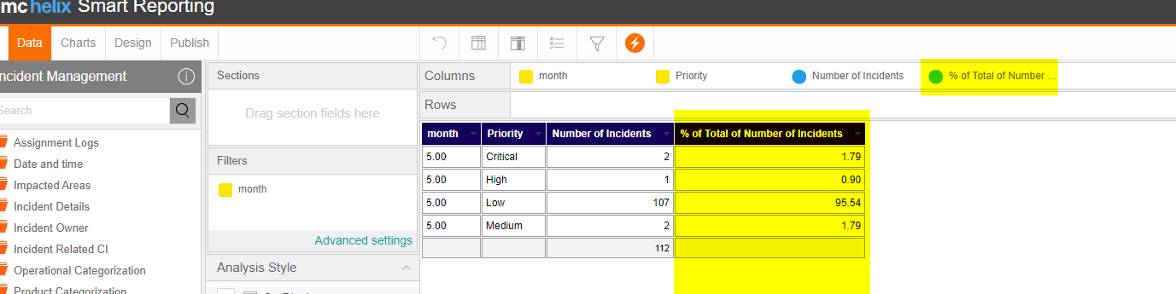
Edit the field format to 2 decimal places
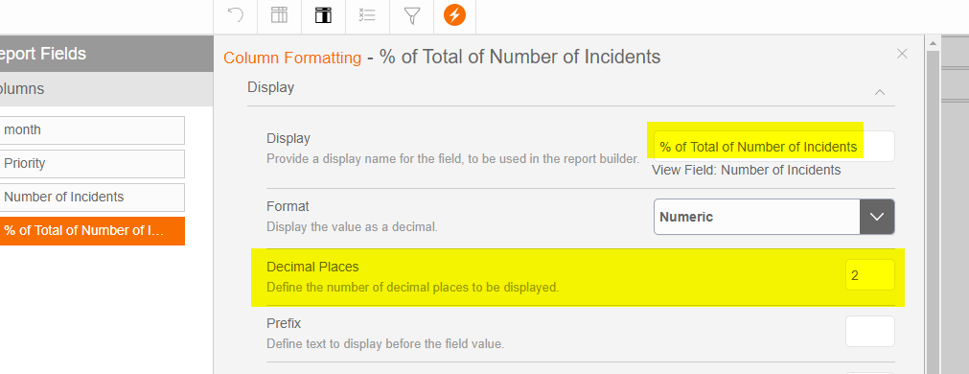

Go to chart design mode and enable label
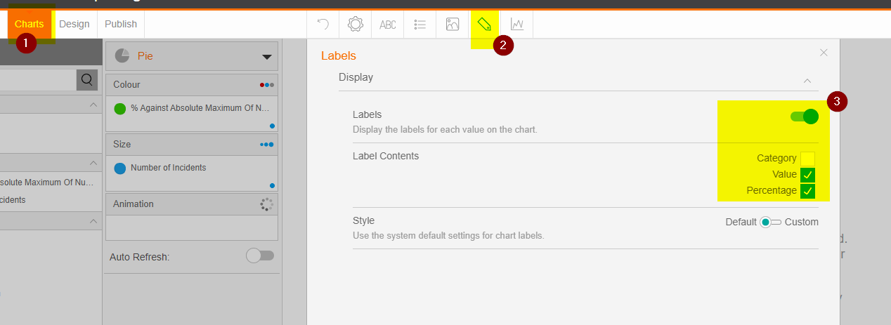
Now, value shows actual percentage value
