- Deployment Diagram
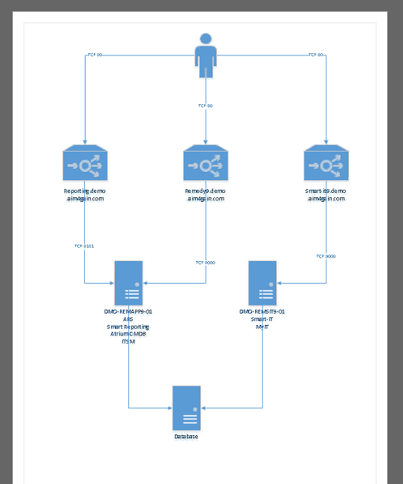
TCP 80: Reverse Proxy Port
Front Facing YellowFin URL : reporting.demo.aim4gain.com
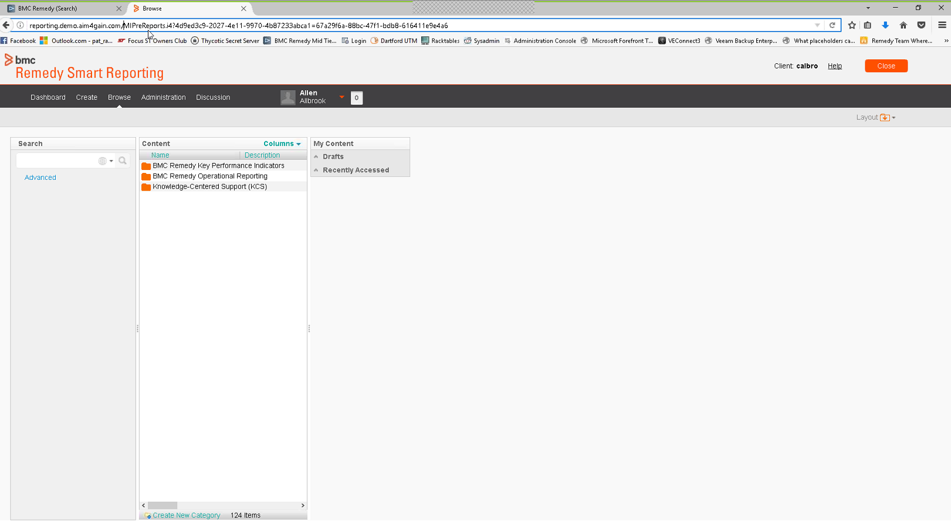

Once User lands up onto Browse and hits on Dashboard, if you see the down status bar, it tries to connect to actual reporting host IP : 10.23.0.8 . This is not accessible from the Client’s machine as only specific ports are opened from client machine

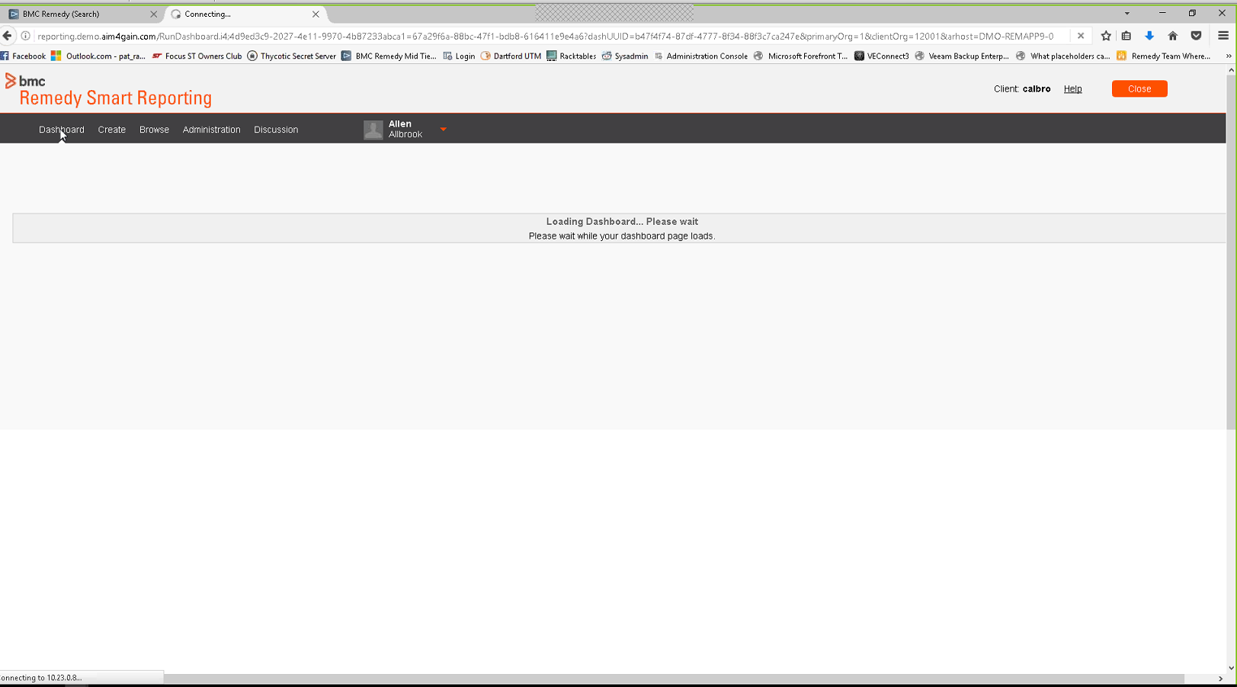

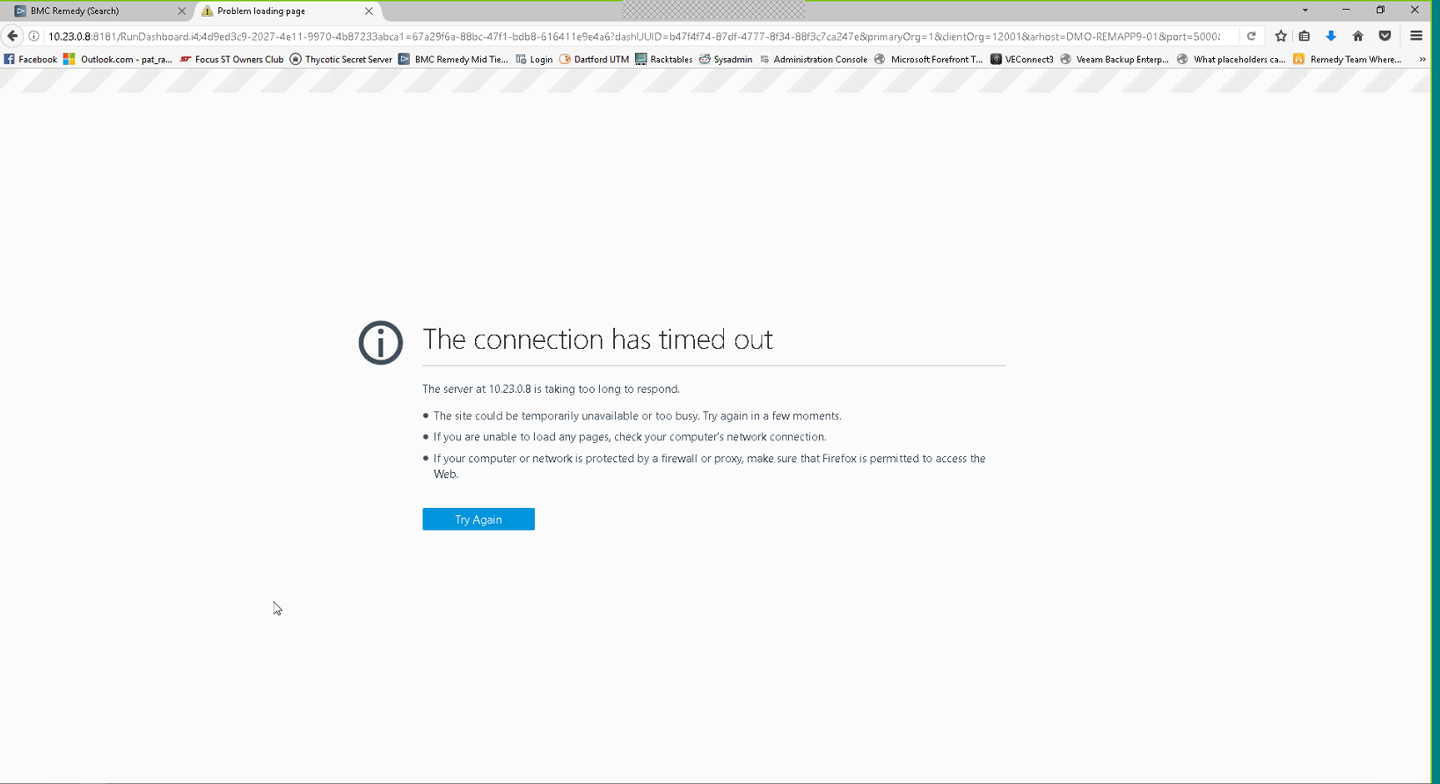

Below is the actual server.xml for the YellowFin server
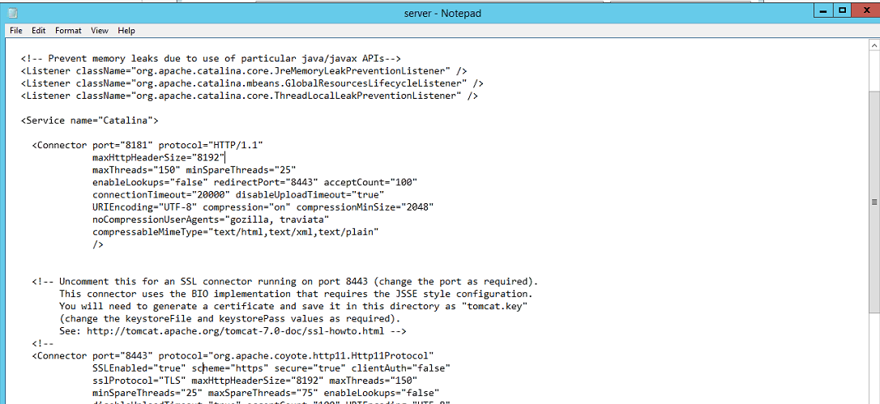

Considering the Proxy settings available we tried to update the server.xml file with some proxy attributes as below and this fixed issue.
