Filter Issue:

I have used append subquery to retrieve today,yesterday,last week,other than last week open tickets. Also I have given filters to it.

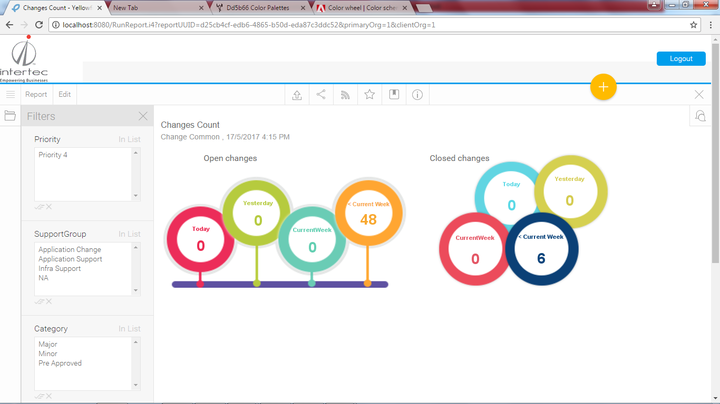

One of the filters is working fine. And the other are not working properly. The one filter which is working fine is taken as common column in append subquery.

What is the issue.

While using append query, we can use filters or not?

Is there any specification while configuring filters to these append subquery reports.