Version 2 – No subquery
In stead of using a subquery I’m now using calculated fields:
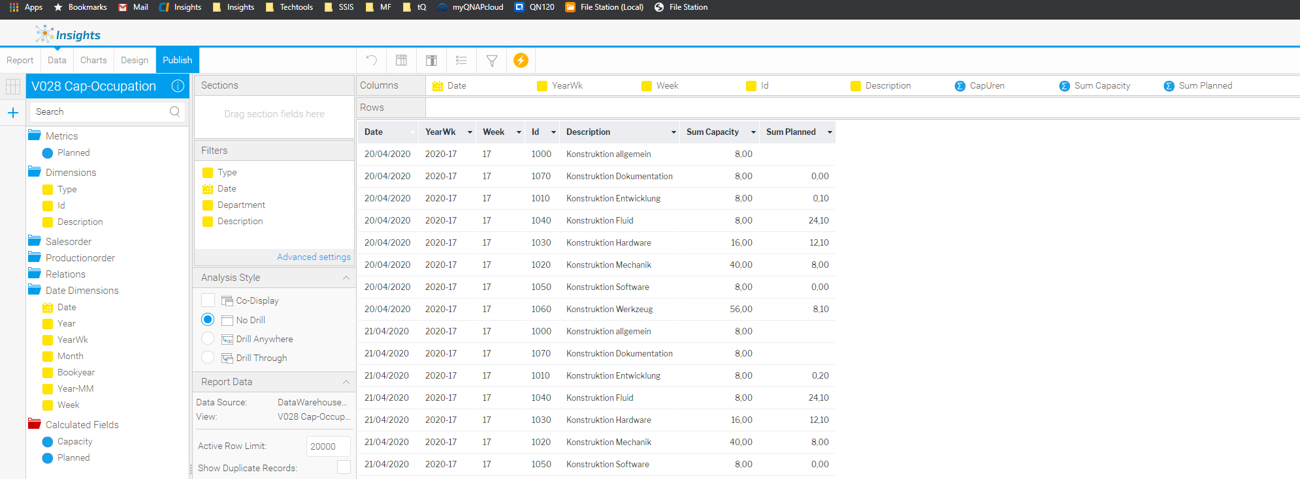
Desired output:
A ‘stacked’ column for sum capacity and a line for sum planned
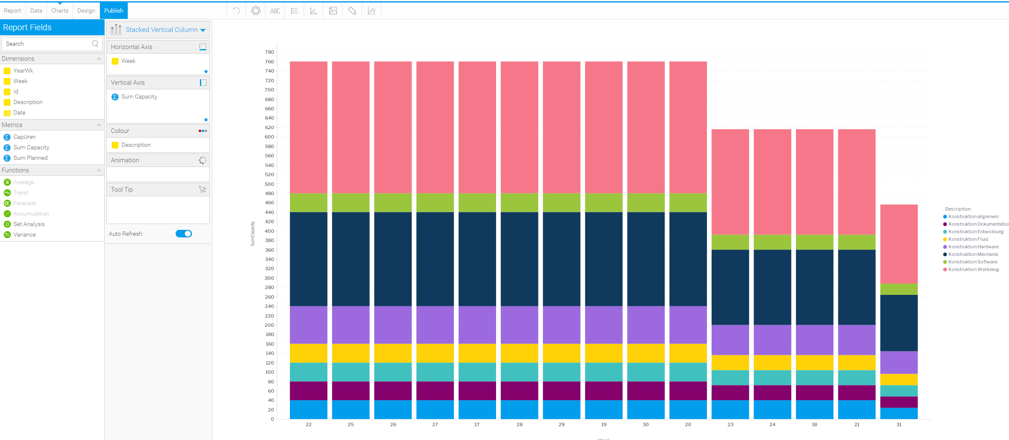
Chosing Vertical overlay as chartttype I’m getting Colour fields can not be applied to this chart when using multiple series
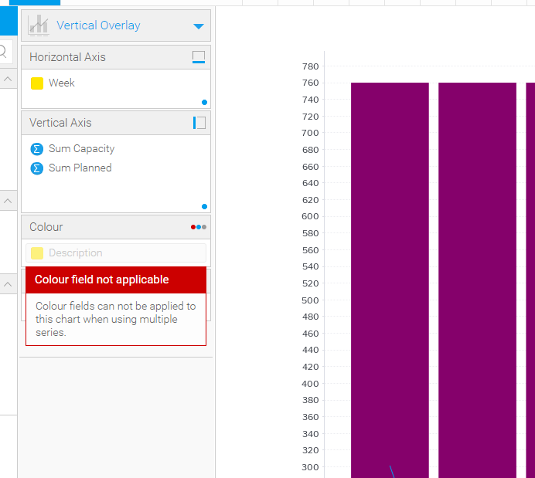
When using ‘physical’ metric on the vertical axis the result is as desired:
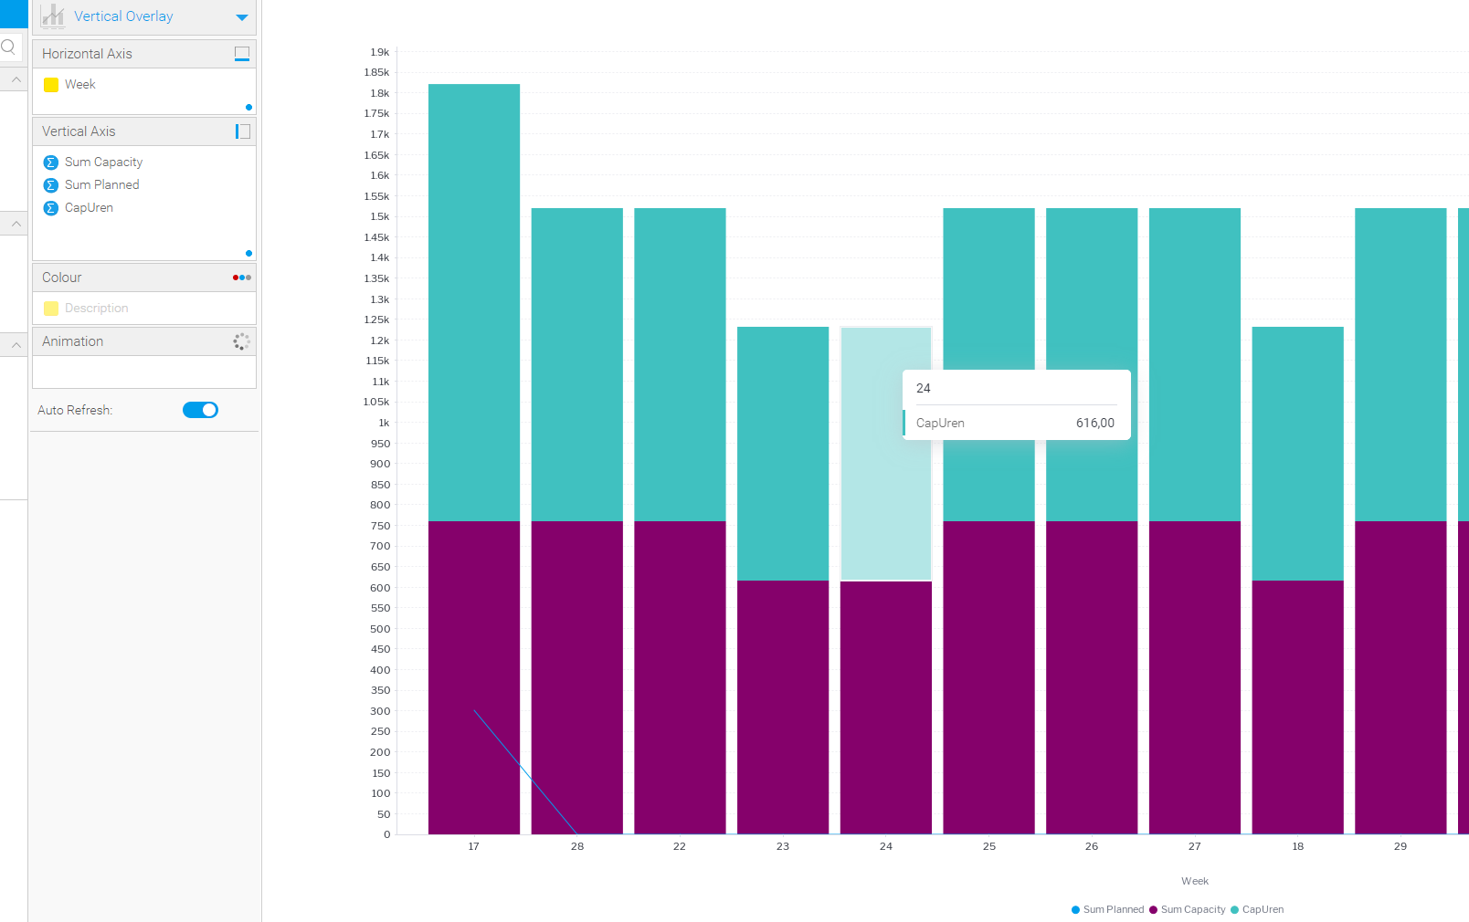
Problem: The contents of the stacked columns is variable!!

