Chart for available capacity vs occupation/used capacity
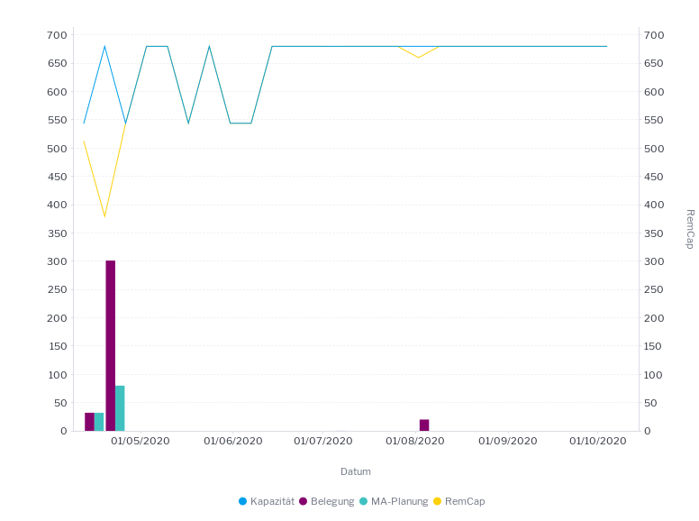
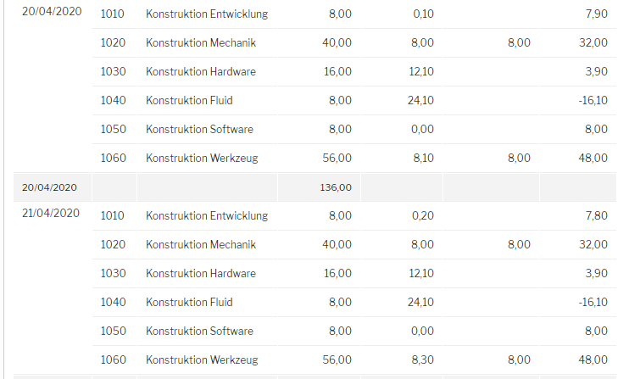
Goal:
Present the green metrics as a stacked column
Present the red metric a line

