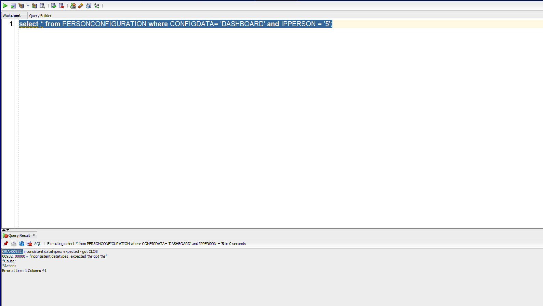

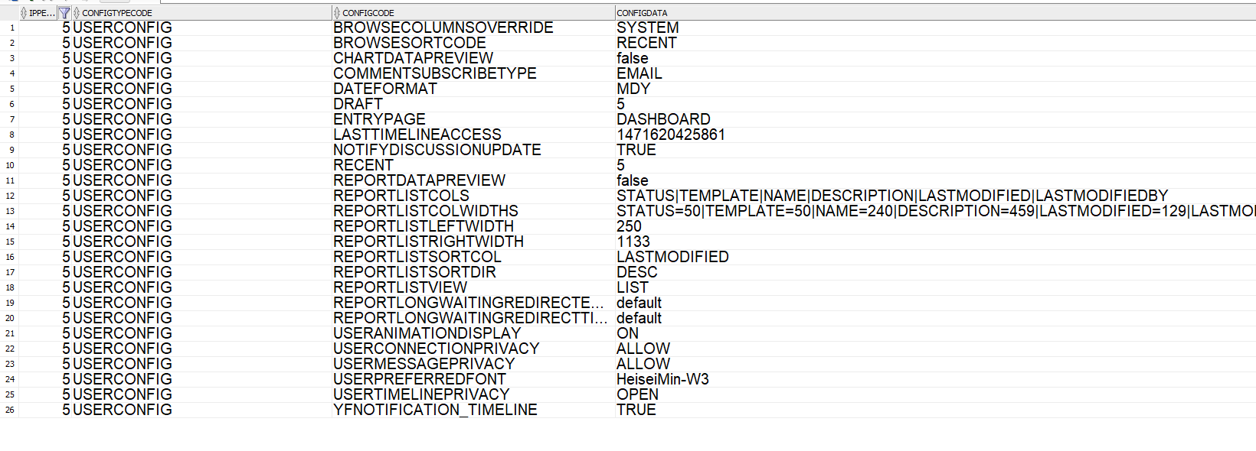

I wand change the CONFIGDATA to “Browse Page” instead of 'DASHBOARD’ for every user.

