While creating Report Data there is issue in Drag and Drop Fields between Calculated fields and database column fields.
I have column like lc_title, and I added a calculated field named Status with calculation like isnull (lc_status.lc_title,’NA’).
Initially if I drag & drop status, it retrieves data.
- Drag and dropped a custom field, data is shown
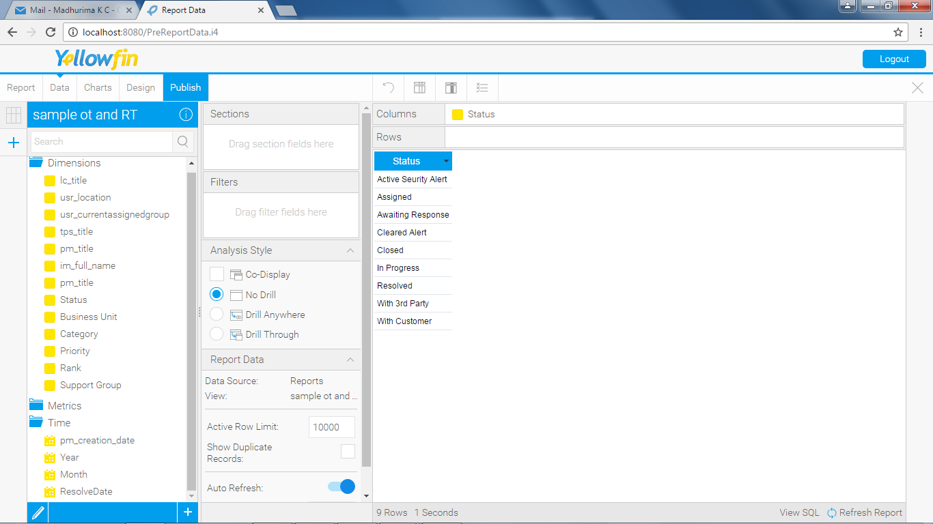

Now I want add another column named pm_title, also added a calculated field priority with calculation like isnull (pm_priority.pm_title,’NA’)
2. Drag and drop pm_title field, it won’t retrieve data as shown below.
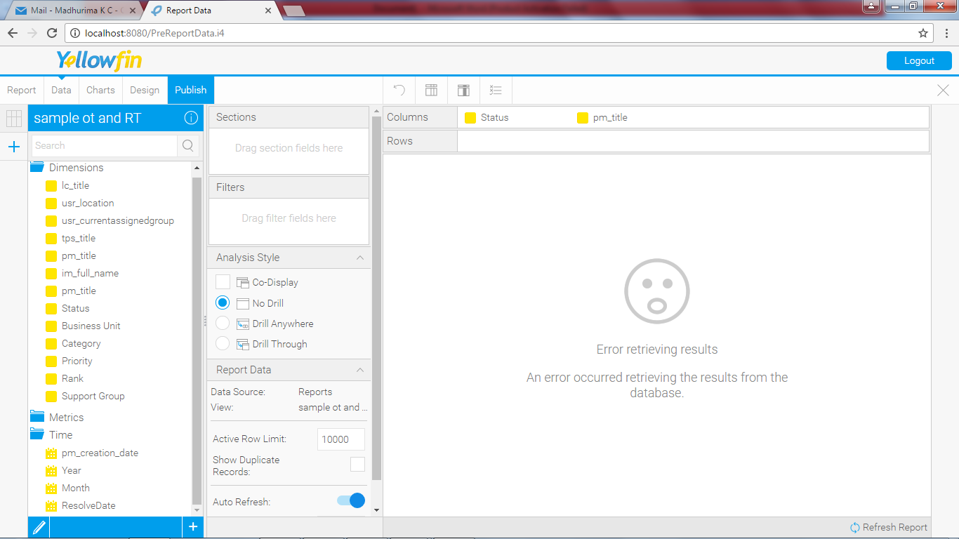

3. So, I tried to drag and drop, lc_title column. Then it retrieved data as shown below. In this manner if priority column (calculated field) then must and should its actual column (pm_title) should be there.
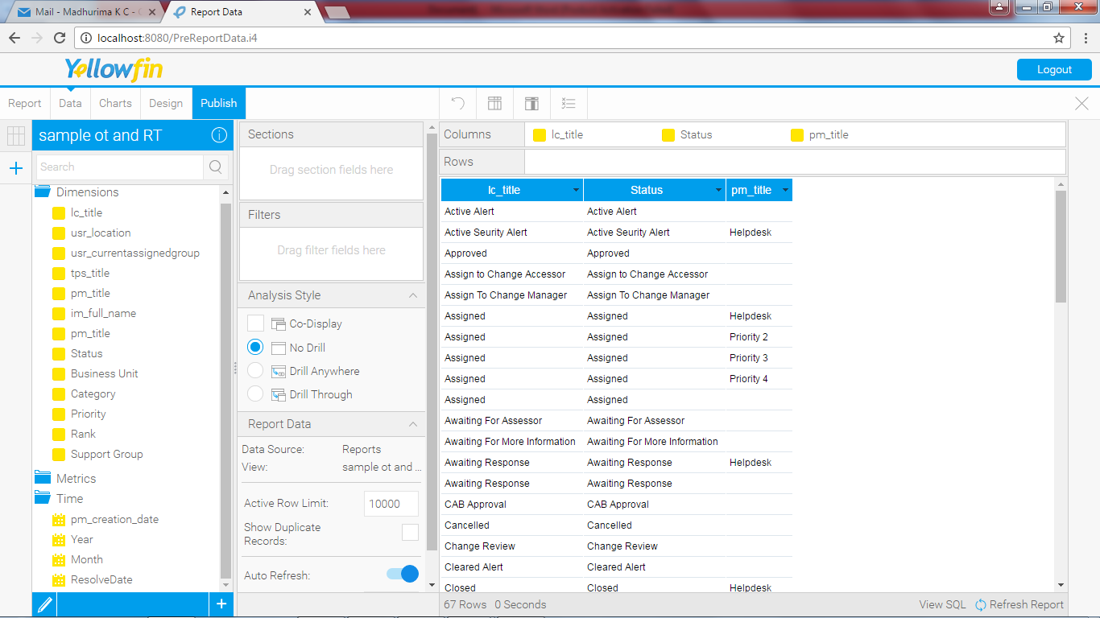
Now what my question is “is it necessary to add both calculated field and its view column field?” And also is there any other option so that we can directly add isnull calculation to the actual view column, rather than using calculation field.

