Application Version: | 8.0.2
java.version: | 1.8.0_171
os.name: | Windows Server 2016
os.arch: | amd64
os.version: | 10.0

Application Version: | 7.4.7
java.version: | 1.8.0_111
os.name: | Windows Server 2012 R2
os.arch: | amd64
os.version: | 6.3

While testing the found following issues
Question 1.

YF 8
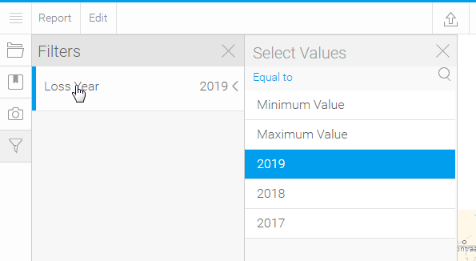
YF 7.4
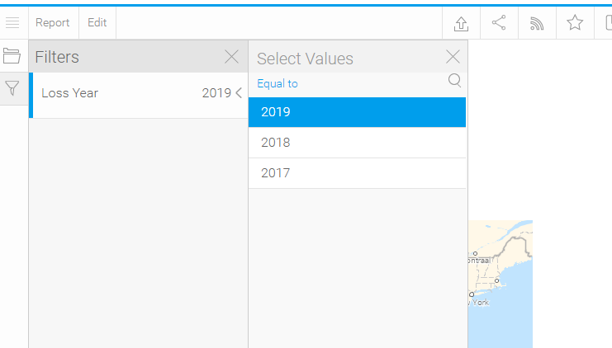
Getting two more value in filter(YF8)
How to hide?
Question 2.

YF7.4-report Graph

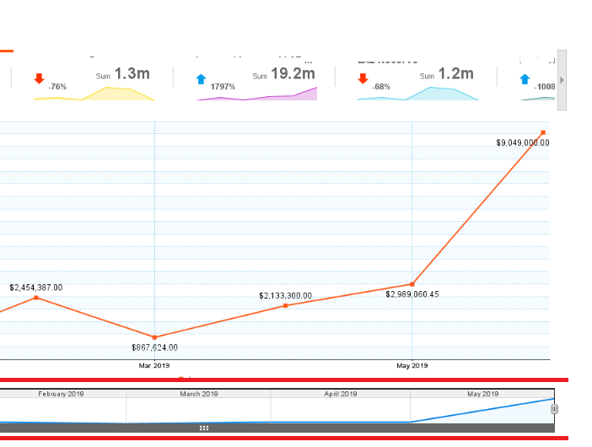

YF 8
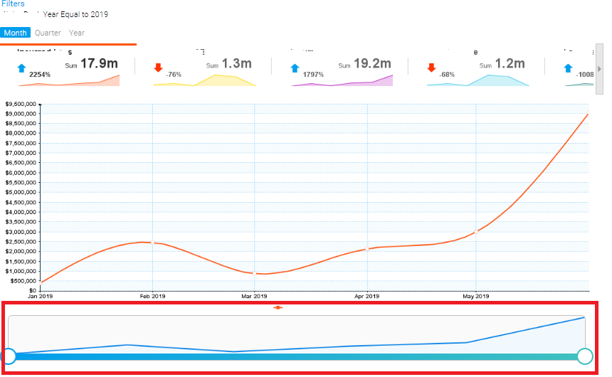
How to display month year in slid bar?

