Application Version: | 8.0.1
java.version: | 1.8.0_121
os.name: | Windows 10
os.arch: | amd64
os.version: | 10.0

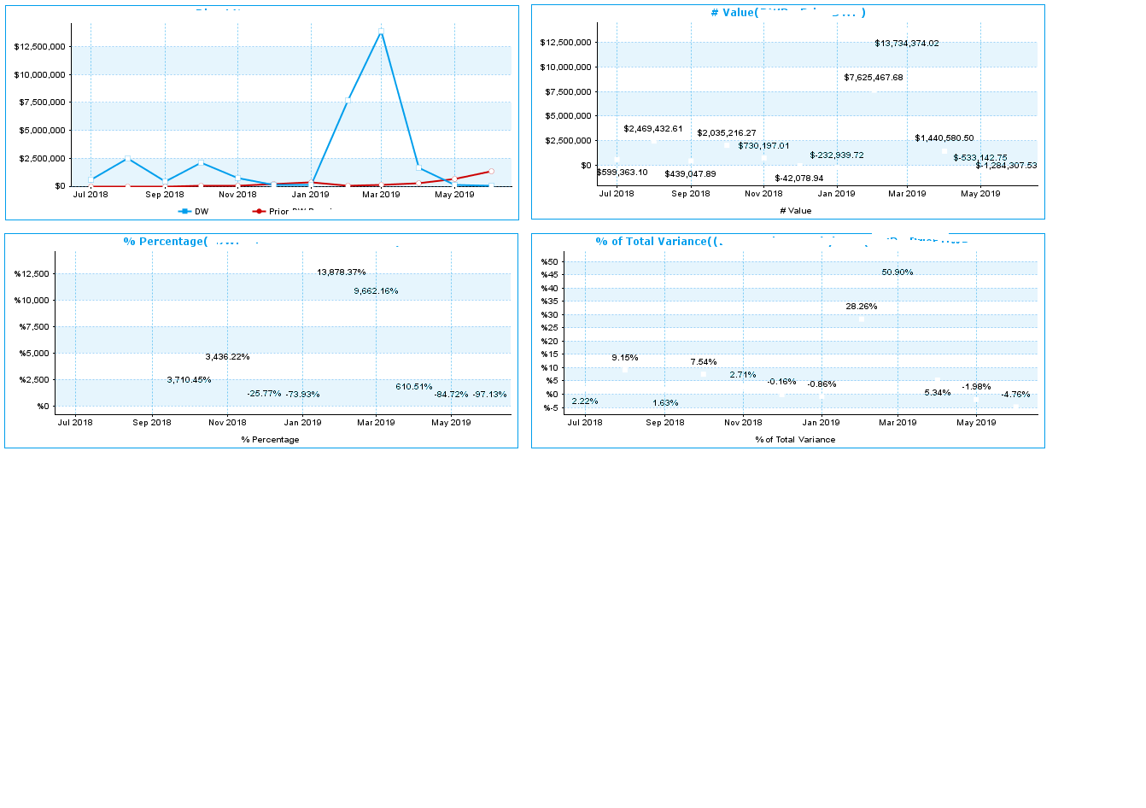

Application Version: | 7.4.7
java.version: | 1.8.0_171
os.name: | Windows Server 2016
os.arch: | amd64
os.version: | 10.0

