I have a dashboard that contains this report
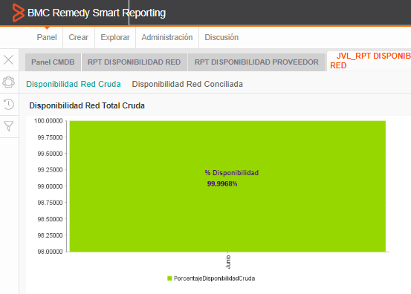
This report shows the % Availability of a customer product.
It considers the 100% of their assets and then it gets the %Availability comparing versus the number of Cis that have incidents involved.
For the tool to keep this 100% value and could be used we had to create a field that never gets modified regarding the existence of a filter.
This is how the report looks like:
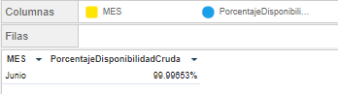
.

This is how the actual report looks like:
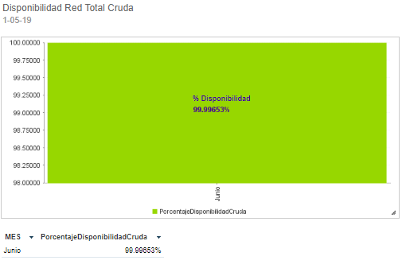

Now I have a NEW requirement and it is that the report has the ability to show the percentage separated across from the customers, however the previous 100% is not valid anymore, now each customer has its own 100% according to the number of Cis they have.
I have a new field that gives me this number, (now 1 per the 100% of the total Cis across different customers and 1 per the 100% for each customer)
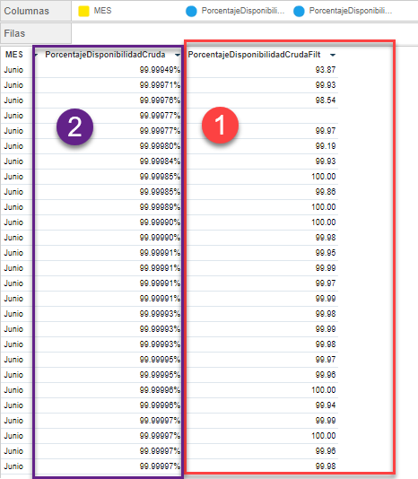
If I add the calculated field that gives me the Availability % (image 1) the first value gets affected (Image 2) and doesn’t show the real % Value it previously had.
And still there’s something else, I want to set the GRAPH to use the value for the customer if in the filter a customer is selected, but if no customer is selected I want to show the first value which shows the 100% for all the customers.
I know I also have to add the field for the customer name into the GRAPH so the availability for each customer gets associated with the name.
Is this possible to create this kind of report we’re trying to do?
Is there a way to accomplish this?
Perhaps not doing 1 single report but creating 2 and drilling down into another report?
Any advise will help thanks!

