<https://community.yellowfinbi.com/knowledge-base/article/google-maps-api-switched-to-pay-as-you-go-model>

In this article it explains that you need an API key (which I have) associated with a credit card (which I have) and shows you where to put the API key, under Administration > Content Settings > Chart Settings > Map Settings > Google Maps API Key::

Expected:

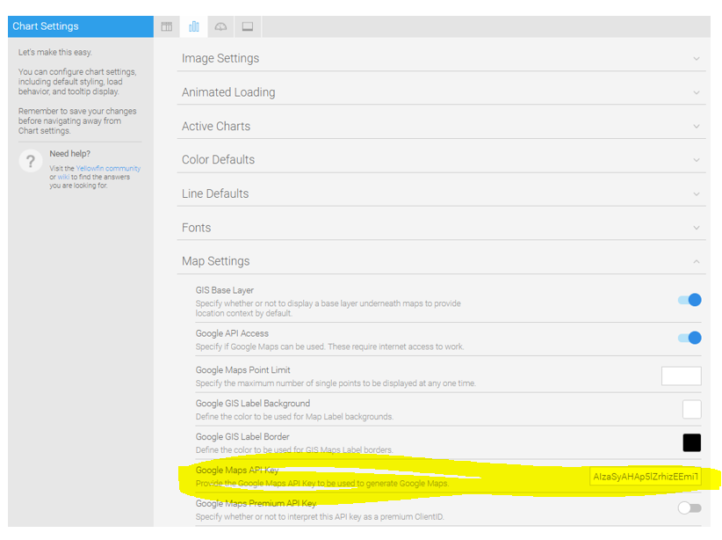

But when I go to that place in BI there is nowhere to put the API key:

Actual:

