Created a report and use Calculated fields so multiple rows from a form should be on one row in the report but that doesnt work, see the attached picture.

System Name 1B has two entries in the form TS:H2:PersonRoleSystem, one for BSO and one for ISO but in the report 1B should only have one row with BSO and ISO on the same row.

BSO: CASE WHEN `TS:H2:PersonRoleSystem`.`Role` = 'Business Solution Owner' THEN `TS:H2:PersonRoleSystem`.`Full Name` END

ISO: CASE WHEN `TS:H2:PersonRoleSystem`.`Role` = 'IT Solution Owner' THEN `TS:H2:PersonRoleSystem`.`Full Name` END

The SQL looks like this:

SELECT DISTINCT

   `TS:H2:PersonRoleSystem`.`System Name`,

   CASE

      WHEN `TS:H2:PersonRoleSystem`.`Role` = 'Business Solution Owner' THEN `TS:H2:PersonRoleSystem`.`Full Name`

   END,

   CASE

      WHEN `TS:H2:PersonRoleSystem`.`Role` = 'IT Solution Owner' THEN `TS:H2:PersonRoleSystem`.`Full Name`

   END

FROM `AR System Schema`.`TS:H2:PersonRoleSystem`

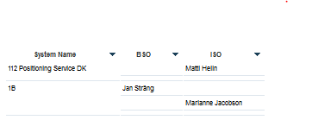

Expected results:

|  |  |  |
| --- | --- | --- |
| SystemName | BSO | ISO |
| 1B | Jan Strang | Marianne jacobson |