Share reports (Link with actual values):

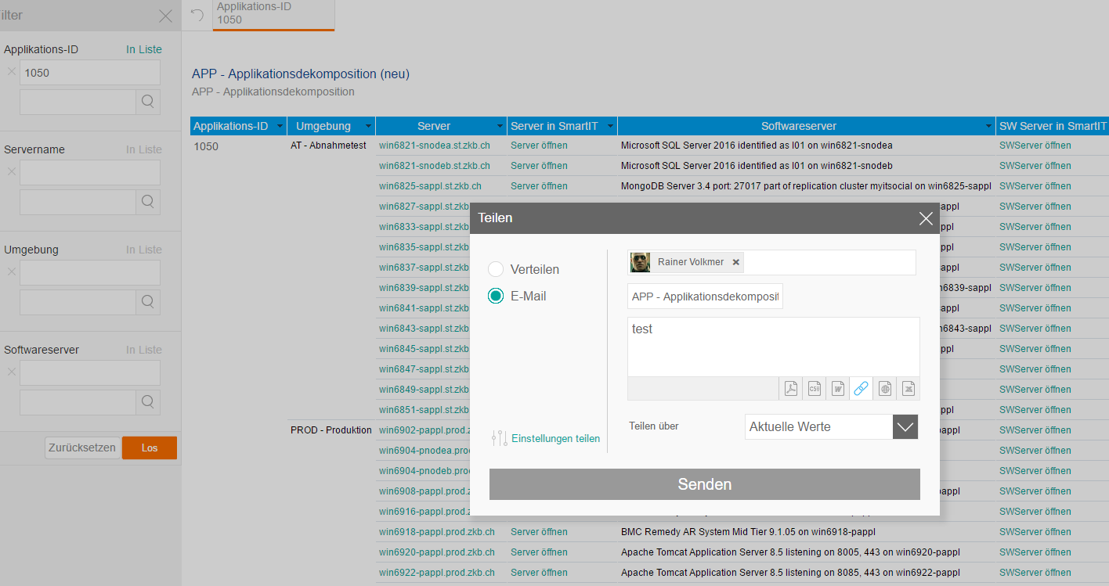

Get the mail with the link:

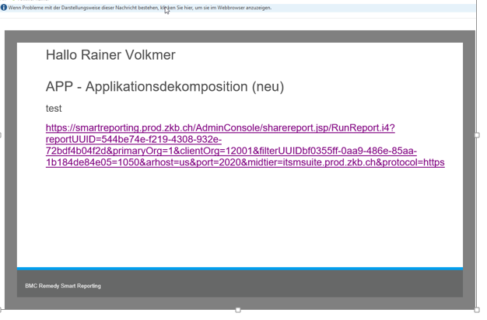
URL: https://smartreporting.prod.com/AdminConsole/sharereport.jsp/RunReport.i4?reportUUID=544be74e-f219-4308-932e-72bdf4b04f2d&primaryOrg=1&clientOrg=12001&filterUUIDbf0355ff-0aa9-486e-85aa-1b184de84e05=1050&arhost=us&port=111&midtier=itsmprod.com &protocol=https

you can see the Filter set to 1050.

Then clearing the filter settings and get all results from DB: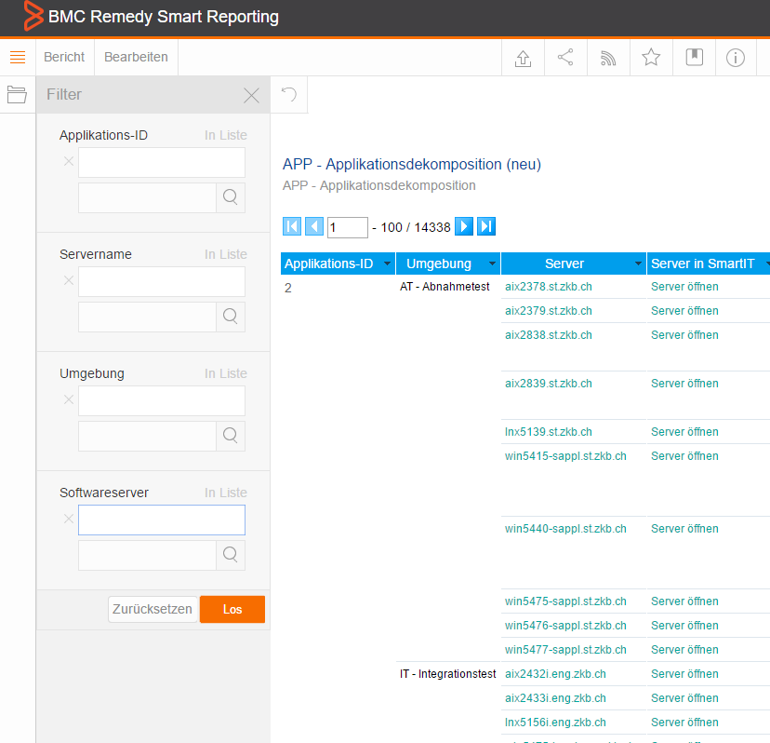

Then logout and click on the link.
It opens, but the filter from the link is not set, it is ignored. You see again the above complete resultlist.

