Report showing summary metrics

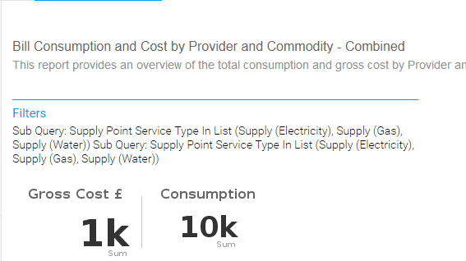

Edit the report and select Summary – no metrics displayed
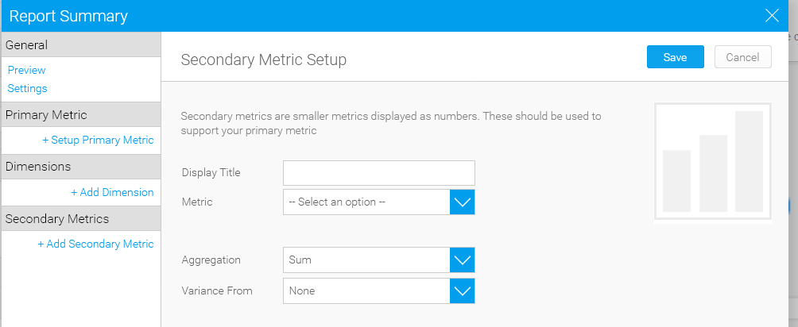

Add a Primary metric
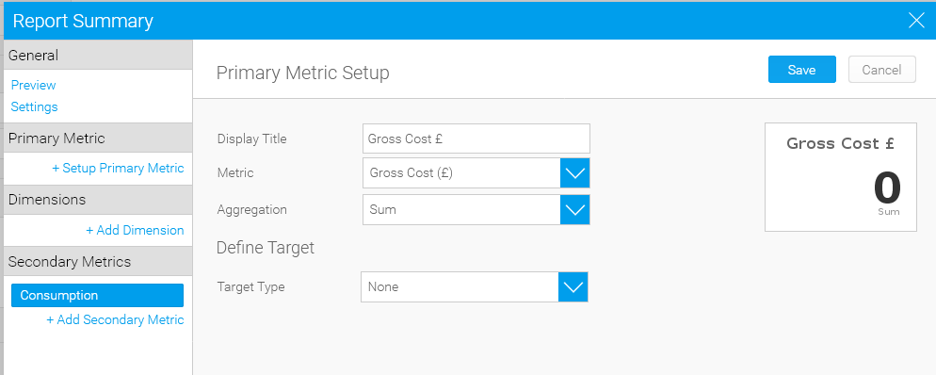

When Save is clicked, the metric disappears
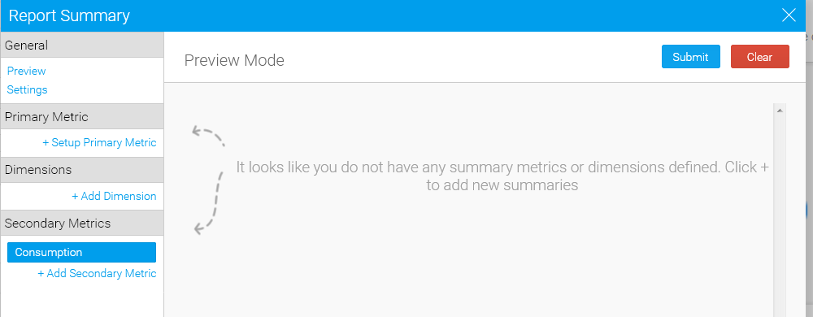

When finally added, Submit
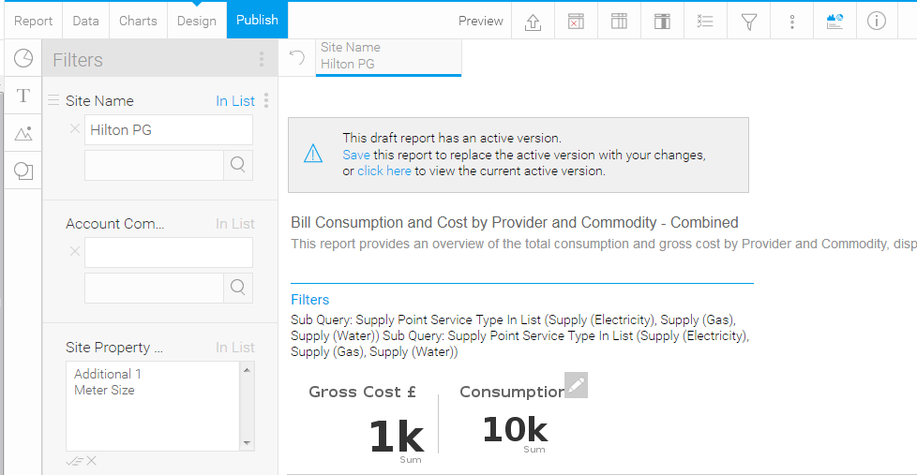

Publish report – summary is visible with values
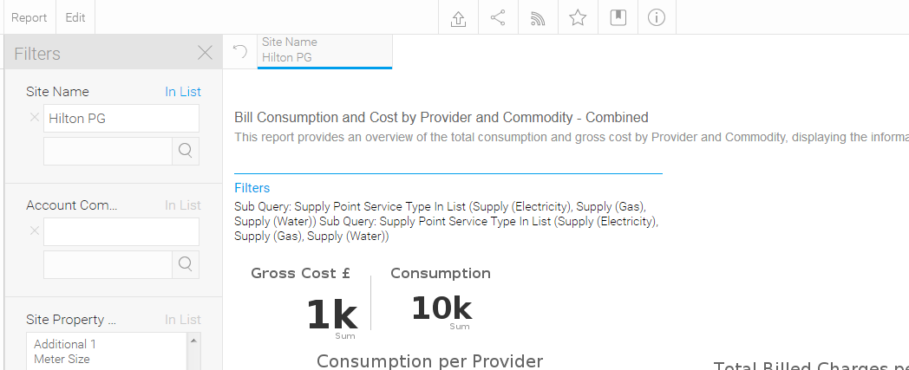

When report is exported and imported into another Yellowfin instance, the summary metrics only show zero and when editing the report, the metrics are not shown
