Report Output
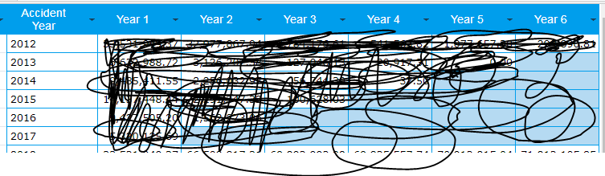
Scenario 1.
Filter is 2012
Year 1 …Year 6 is column name
Accident Year 2012 - year 1, displaying Accident 2012 value …. In year 2 displaying 2013 value….
Accident Year 2013 - year 1, displaying Accident 2013 value …. In year 2 displaying 2014 value….

I want
Column name “Year 1” = display 2012 as column name
Column name “Year 2” = display 2013 as column name
Refer Desirer output SS.

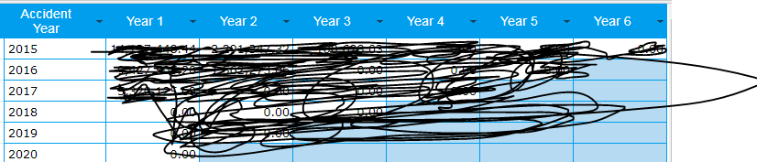
Scenario 2.
Filter is 2015
Year 1 …6 is column name
Accident Year 2015 - year 1, displaying Accident 2015 value …. In year 2 displaying 2016 value….
Accident Year 2016 - year 1, displaying Accident 2016 value …. In year 2 displaying 2017 value….

I want
Year 1 = 2015
Year 2 = 2016…..

BASED ON ACCIDENT YEAR, REPORT (YEAR COLUMN) COLUMN NAMES SHOULD BE CHANGE AND DISPLAY

Desirer output