1. 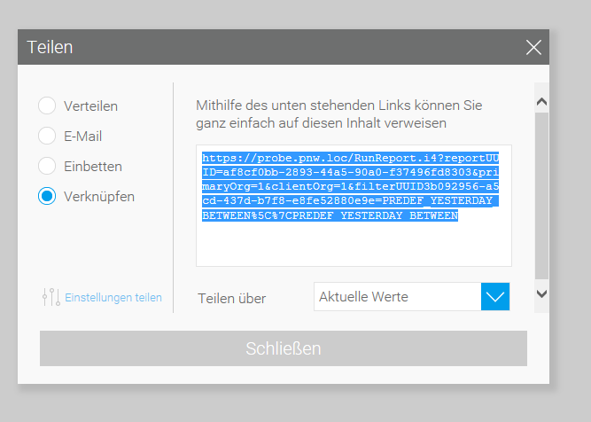

2. Copy Link:
https://probe.pnw.loc/RunReport.i4?reportUUID=af8cf0bb-2893-44a5-90a0-f37496fd8303&primaryOrg=1&clientOrg=1&filterUUID3b092956-a5cd-437d-b7f8-e8fe52880e9e=PREDEF_YESTERDAY_BETWEEN%5C%7CPREDEF_YESTERDAY_BETWEEN

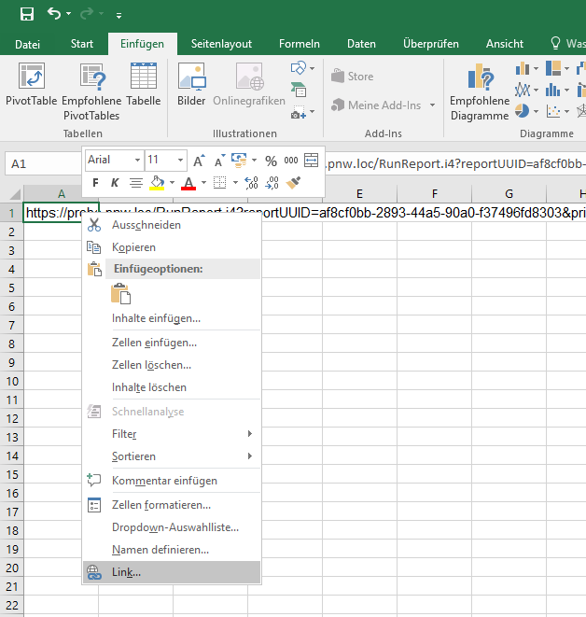
3. Insert into Excel and right cklick on cell and choose Link…

4. Added the link in "Adresse"

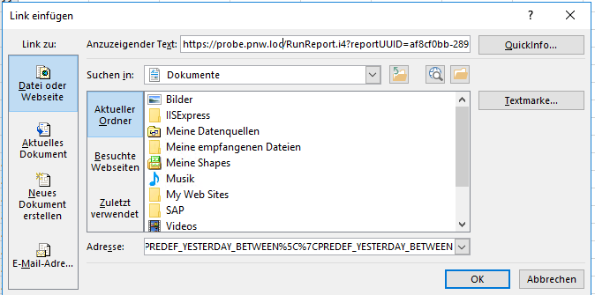

5. Click on the new link

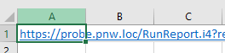

6. Browser is open and login:

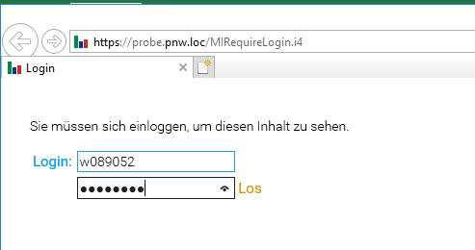

7. After Login it comes this error message

