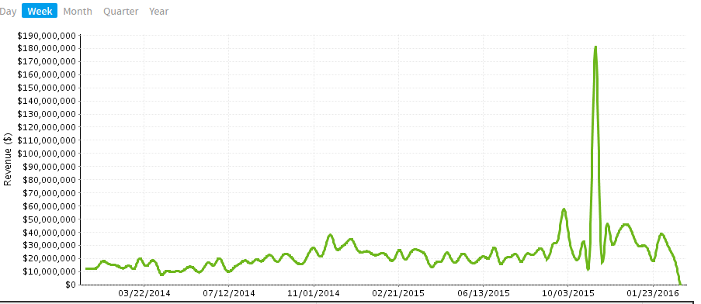

This needs to be kept in the date format

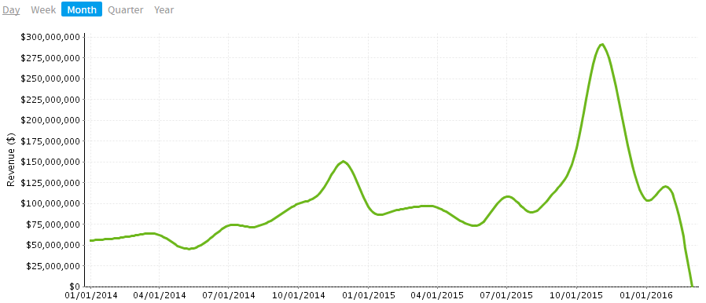

Can you change this to Month Name while moving from Week to Month
Eg: Jan, Feb, Mar,.. when Month option is clicked instead of giving dates

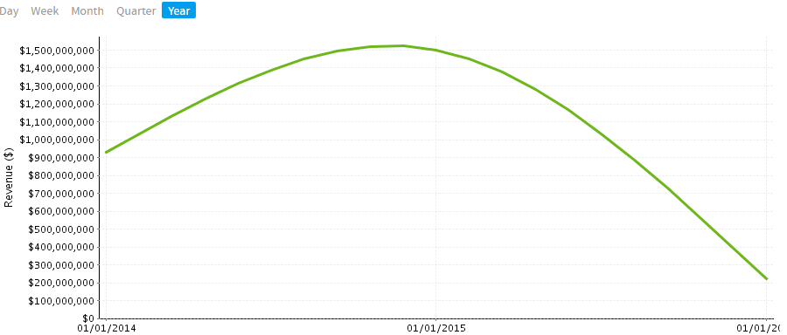
f
Can you change this to Year number
Eg: 2014, 2015 instead of dates

