I am trying to link a parent filter (Customer) to a child filter (Datalink)

Example 1 - No linkage
All of my values are showing up, but obviously no filtering for datalink by customer (No Linkage)
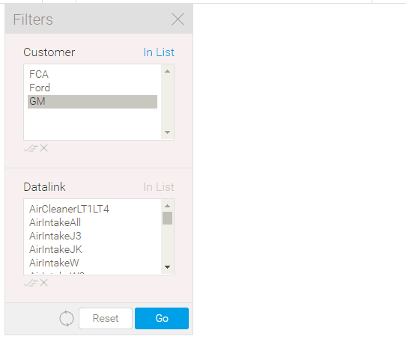

Example 2 - "Datalink" linked to parent "Customer"

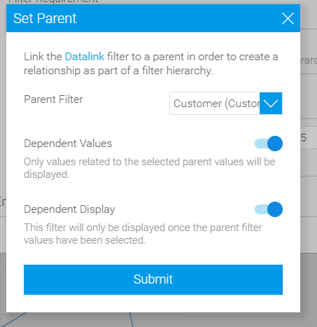

Now, no values are shown and datalink filter has completely disappeared (child filter disappearing is normal to my knowledge)
What is abnormal is that now I cannot select any customer criteria, it has vanished.
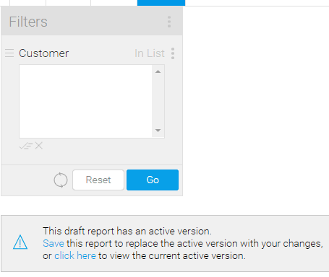

Thank you,

