I have data as follows:
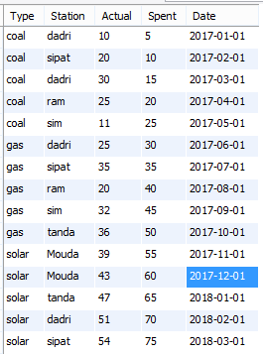
My Child Report is,
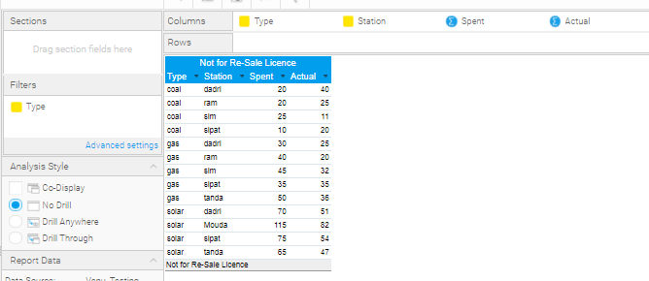
My Master report data is,
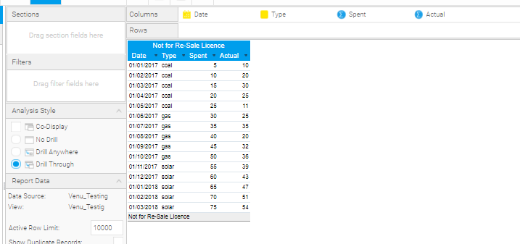
Also respective chart is with set analysis is,

- Type = coal
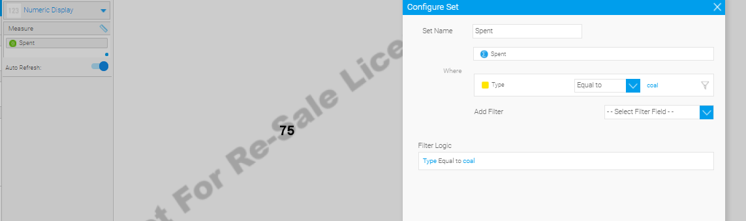

- Type=gas

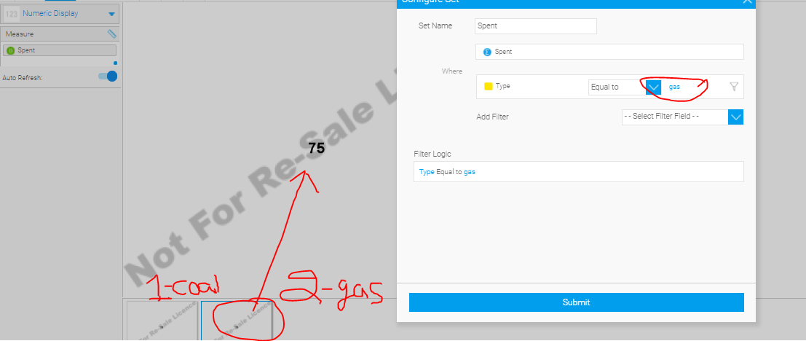
- Type = solar
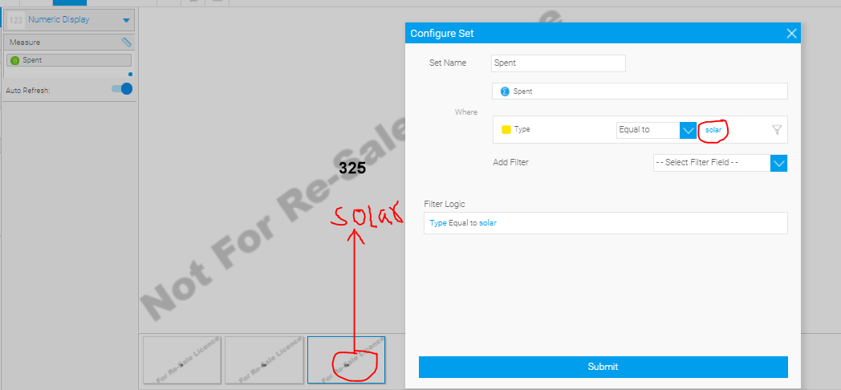

Related content is as follows:
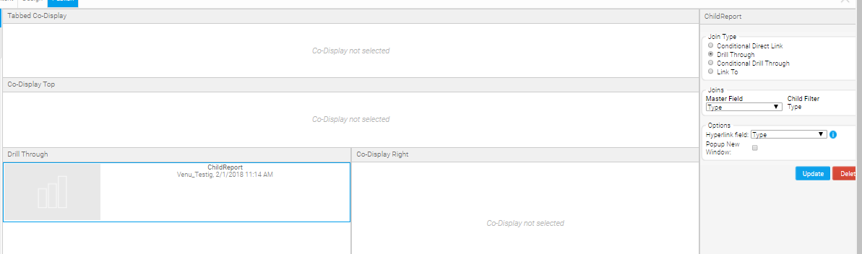
Here is my final designed report:
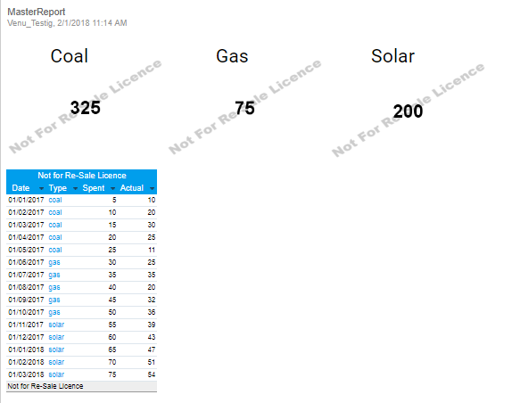
Now my requirement is, When I clickt on Coal data 325 then the Child report data should be Type=Coal, if I click on Gas data 75 then the child report data should be Type=gas…

