1. **Jdk version**



1. **Attached the jsp file.**
2. **Java path**

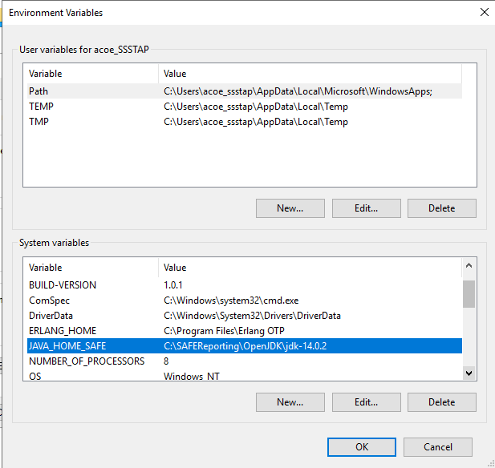

1. **Error log on yellowfin upgrade**

Error encountered: java.lang.reflect.InvocationTargetException

java.lang.reflect.InvocationTargetException

                at java.base/jdk.internal.reflect.NativeMethodAccessorImpl.invoke0(Native Method)

                at java.base/jdk.internal.reflect.NativeMethodAccessorImpl.invoke(NativeMethodAccessorImpl.java:77)

                at java.base/jdk.internal.reflect.DelegatingMethodAccessorImpl.invoke(DelegatingMethodAccessorImpl.java:43)

                at java.base/java.lang.reflect.Method.invoke(Method.java:568)

                at com.hof.patch.util.DBUtil.decryptPassword(DBUtil.java:177)

                at com.hof.patch.util.DBUtil.getDBInterface(DBUtil.java:112)

                at com.hof.patch.process.job.UpdateSchemaJob.run(UpdateSchemaJob.java:104)

                at com.hof.patch.PatchInstaller.runInstallJobs(PatchInstaller.java:478)

                at com.hof.patch.izpack.panels.YFPatchProcessPanel$YFProcessPanelWorker.run(YFPatchProcessPanel.java:299)

                at java.base/java.lang.Thread.run(Thread.java:833)

Caused by: java.security.ProviderException: javax.crypto.ShortBufferException: Output buffer invalid

                at java.base/com.sun.crypto.provider.GaloisCounterMode.engineDoFinal(GaloisCounterMode.java:408)

                at java.base/javax.crypto.Cipher.doFinal(Cipher.java:2205)

                at com.hof.util.CryptoHelperSimple.decryptAes(CryptoHelperSimple.java:157)

                at com.hof.util.CryptoHelperSimple.decryptFromString(CryptoHelperSimple.java:90)

                at com.hof.util.Crypto.decryptFromString(Crypto.java:352)

                at com.hof.pool.DBConnectionManager.decryptPassword(DBConnectionManager.java:864)

                ... 10 more

Caused by: javax.crypto.ShortBufferException: Output buffer invalid

                at java.base/com.sun.crypto.provider.GaloisCounterMode$GCMDecrypt.doFinal(GaloisCounterMode.java:1366)

                at java.base/com.sun.crypto.provider.GaloisCounterMode.engineDoFinal(GaloisCounterMode.java:406)

                ... 15 more

--- Yellowfin Patch Installation Failed ---

Date: 2024-08-01 17:48:55 (+1000)

1. Error while upgrading from yellowfin reports database **from 9.2 to 9.7 version**.

