This is what I want but when I change this to a vertical chart from an Auto it makes me put in a numeric value in color and will not let me put in an alphanumeric in the color.
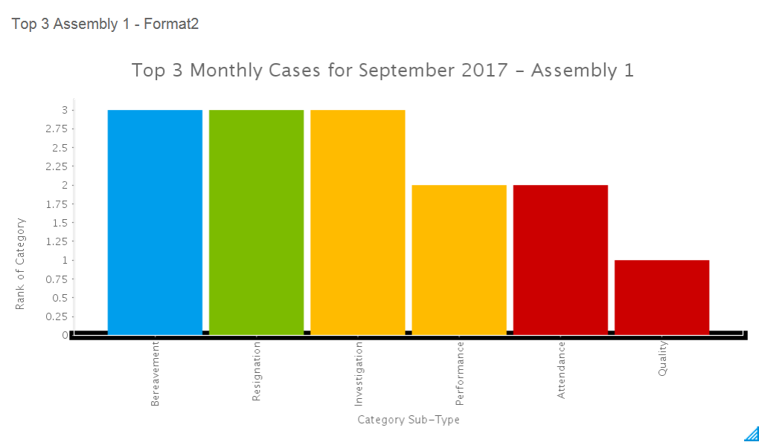

This is my current chart and I am wanting it to look like the above with different colors based on Category.
