Requirement
- To send out HTML email every morning from Monday to Friday

Issue
- Yellowfin broadcast does not reliability generate emails based on the default filter values

Background
- Component reports that make up the broadcast report are based on existing dashboard, therefore largely replicate how the original reports work
- The broadcast is a co-joint report meaning it is composed of many other reports. Each of these reports have different date requirements but are all driven off a “Report Date”
- Yesterday’s date is passed to “Report Date” parameter
- Text headings in the report change depending if the date passed is today’s date or not
Configuration
- Broadcast User Prompt Filter only has two options
  - 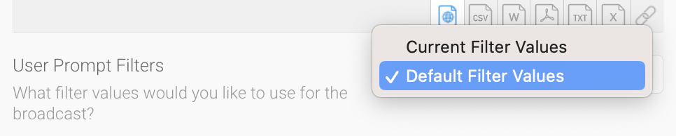
  - I use “Default Filter Values”
- Report filters
  - Report Date is the only filter on this report
  - Report Date is defaulted to Current Date – 1 Day
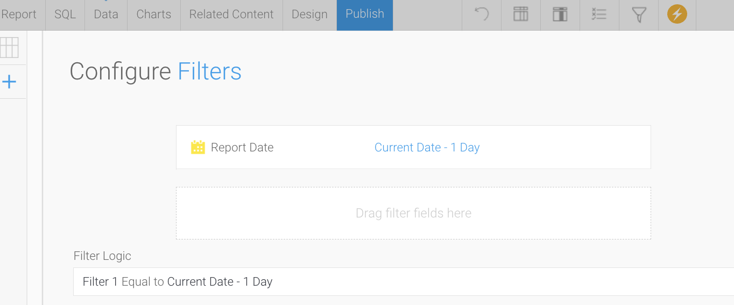

This is how the Broadcast was configured:
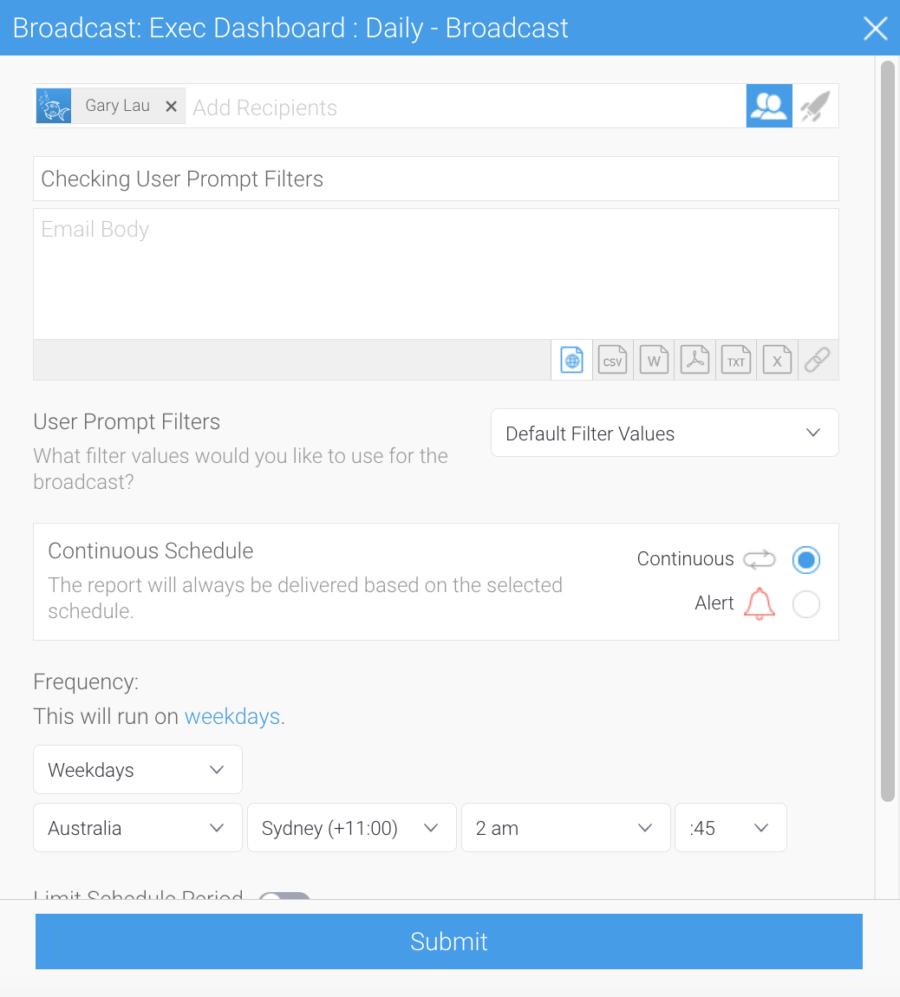

This is what the report looks like when OPENED MANUALLY:
- Today’s Date is Mon 15th Jan
- The default for report date is correctly set to 14/1/204 (correct)

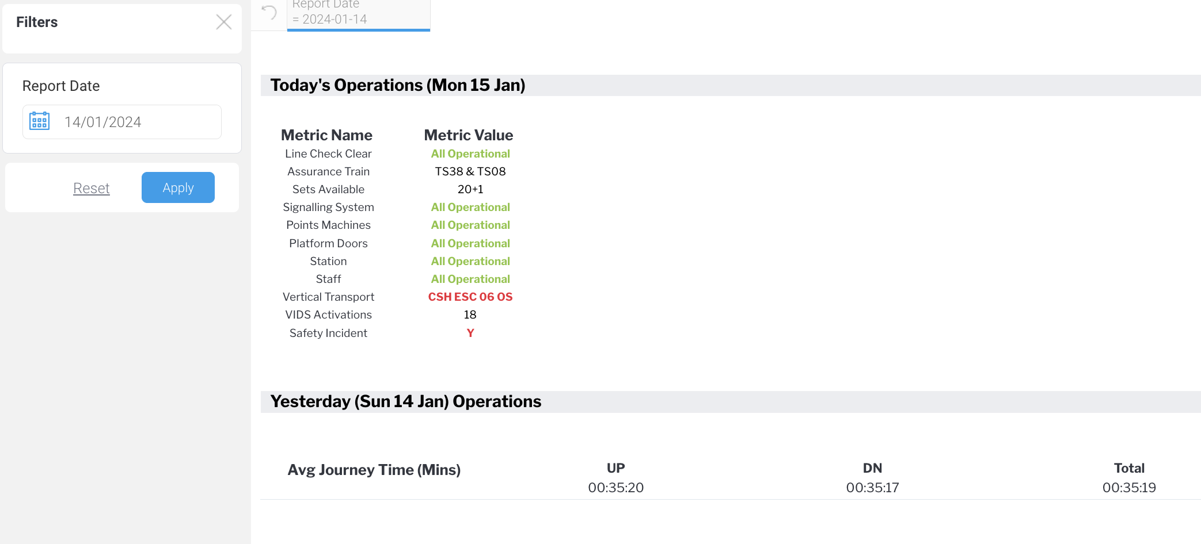

When broadcasted this morning, BROADCAST uses day before (incorrect) as the report date:
