Trial on MS Edge and Chrome. Chrome trial was first time to use chrome at that website – so no cookies or other web site baggage.
Also tried on a different computer. Same issue.

Results after login:

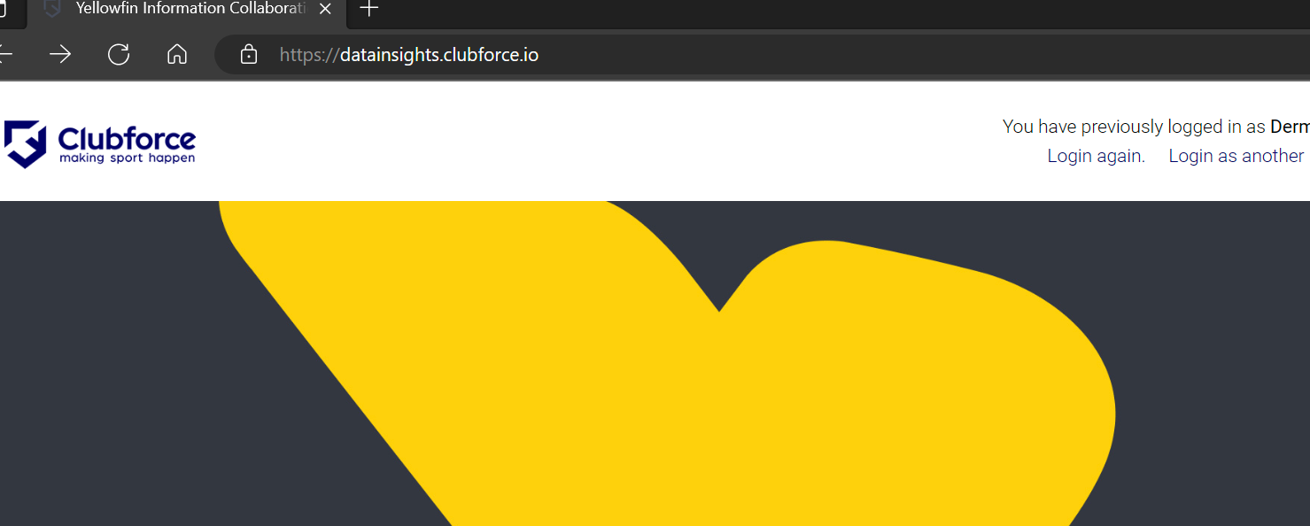

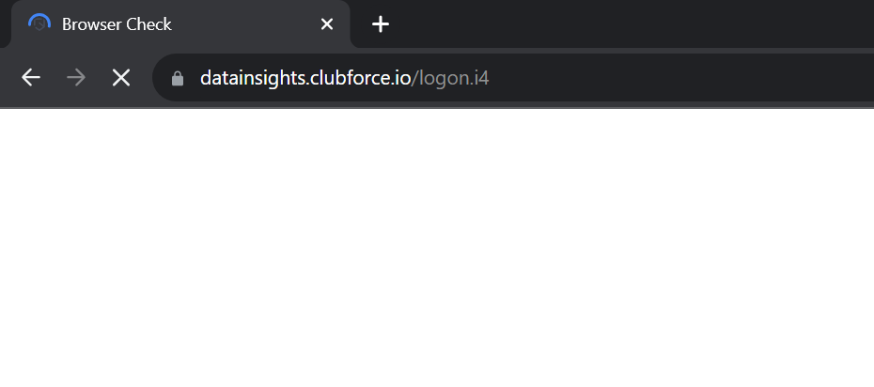

Minutes go by. Just continues to be busy with plain white page. Finally gives up and remains on that blank page.
Refresh triggers it to retry. No change to the white screen. Gives up eventually, remaining on the blank page.

