YellowFin – App /Web Server Configuration

Contents
Preface 1
App Server Configuration 1
Web Server Configuration 4
Important Note 5

Preface
App Server Detail
 | IP Address | 10.40.25.47
 | Host Name | YFSQLDEV
Web Server Detail
 | IP Address | 10.40.25.49
 | Host Name | UPGINSTALLERORA
Note: Above hosts are used for reproducing the issue with same setup as of LM client.

App Server Configuration

- Open “server.xml” file from “C:\SAFEReporting \appserver\conf\” folder and add a property “address” with value “0.0.0.0” to the Connector html as shown in the image.
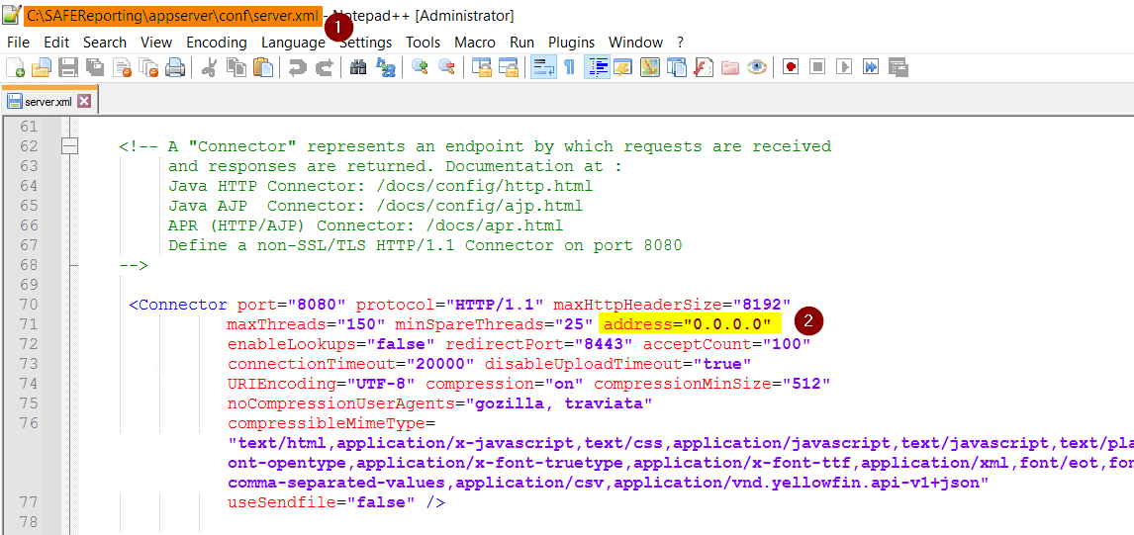

- In the same “server.xml” file, add a property “address” with value “0.0.0.0” where AJP is defined (ref below image).
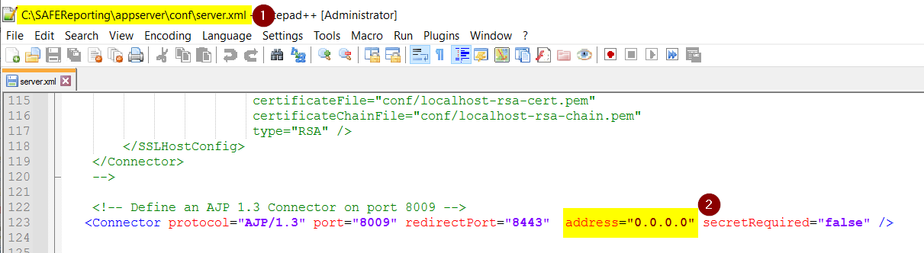
- Open “Safe Configuration” (App Server), ensure there is NO Hostname, protocol, or port specified as shown in the image.
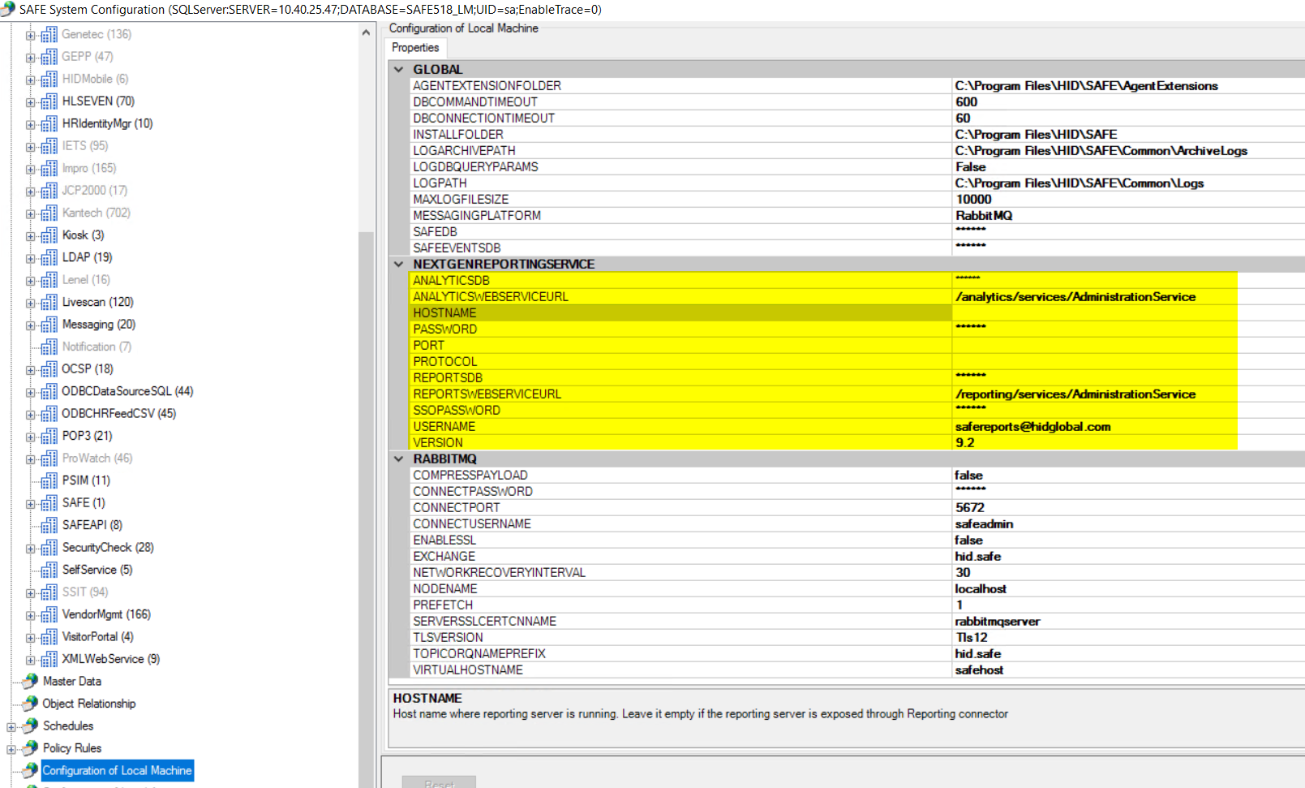
- Ensure All SAFE Services and SAFE Reporting services are up and running in App Server.
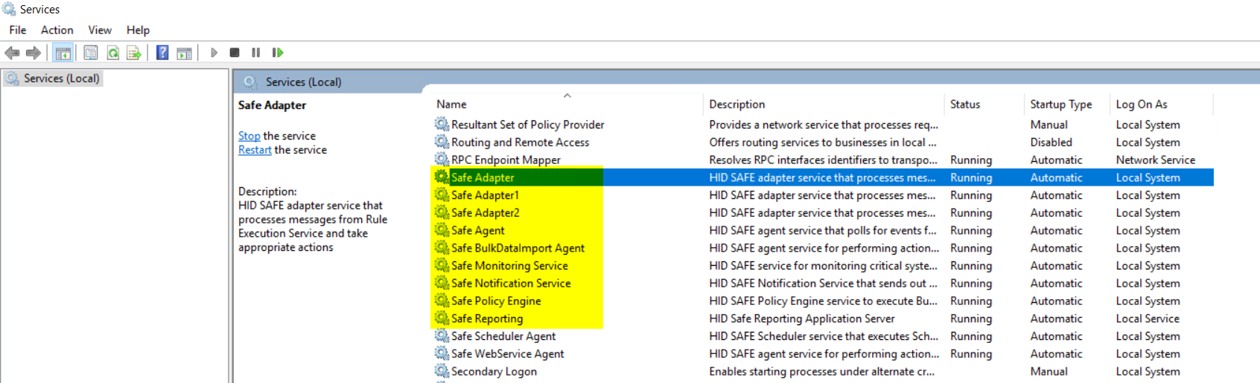

- Open command prompt in Admin mode and type “netstat” command to check the status of port and web server connectivity.

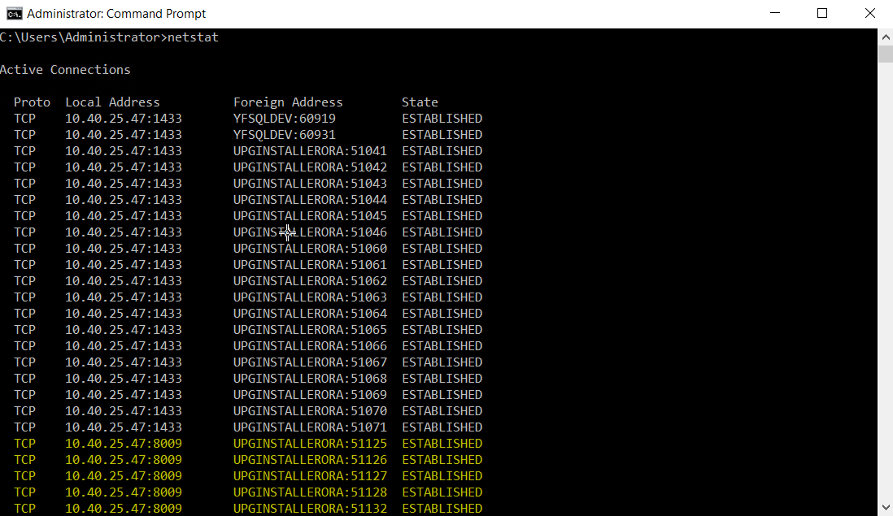

Web Server Configuration

- Open “workers.properties” file from “C:\SAFEReporting\ReportingConnector\” folder. Update the worker1.host value with App Server’s IP Address (in our case it’s 10.40.25.47) as shown in the image.
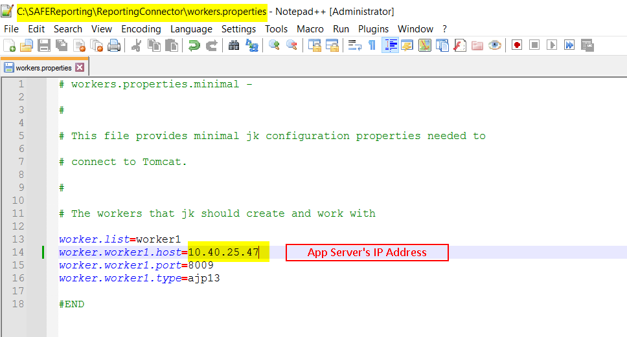

- Open “Safe Configuration” (Web Server), ensure there is NO Hostname, protocol, or port specified as shown in the image.

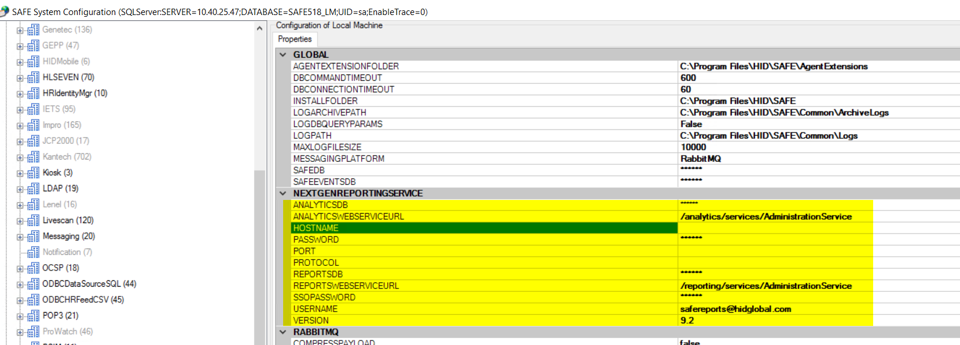

- Open command prompt in Admin mode and type “netstat” command to check the status of port and App server connectivity.

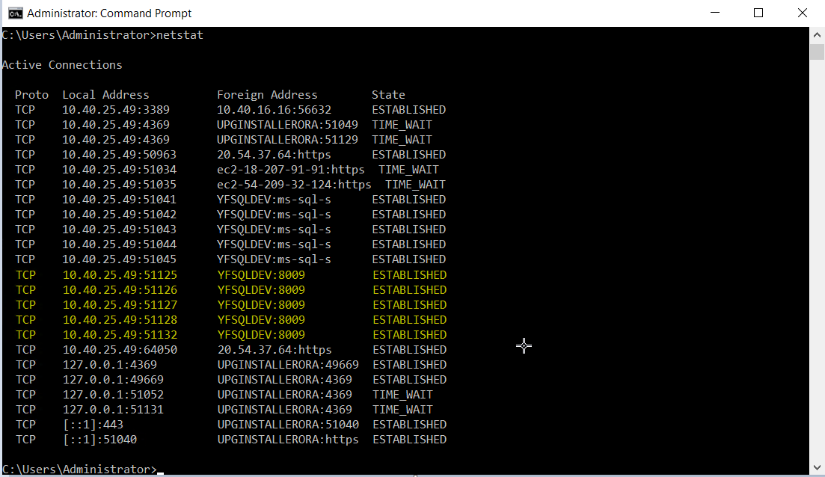

Important Note

- After the changes in the files, restart the “Safe Reporting Service” in App Server and do IISReset in both App Server and Web Server.
- If the “netstat” doesn’t show server’s connectivity status, then launch the SAFE UI in web server. Login and navigate to SAFE Reporting module. Now, check the netstat in the command prompt.

