In View
[Calculated Fields--> Formula Builder--> filter group]
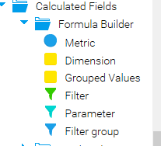
I am going to add Filter Group
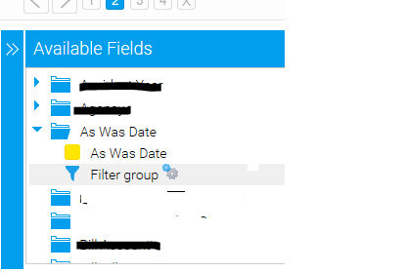

Now in filter group I am adding two condition
1.Date is equal to "Manual User Entry"(User selecte date-Input from report)
2. Date is Null
1.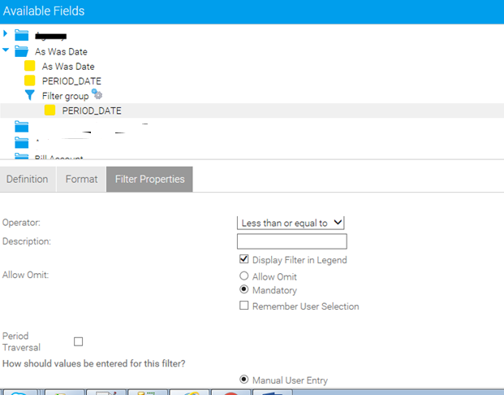

Defined as above properties and save as “User Date”

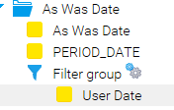
2.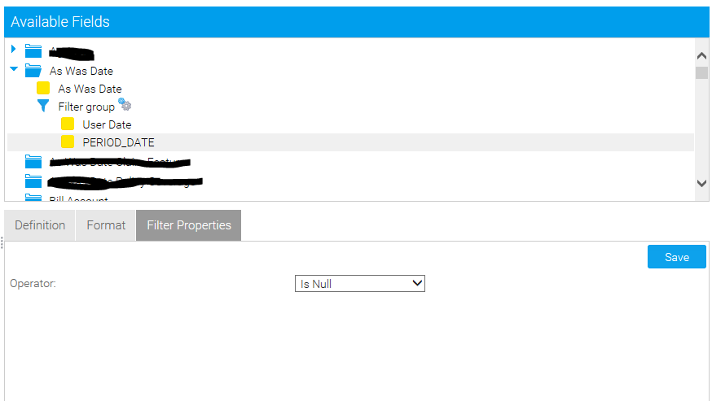
Defined as above properties and save as “N Date”
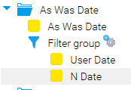

Activated Filter group

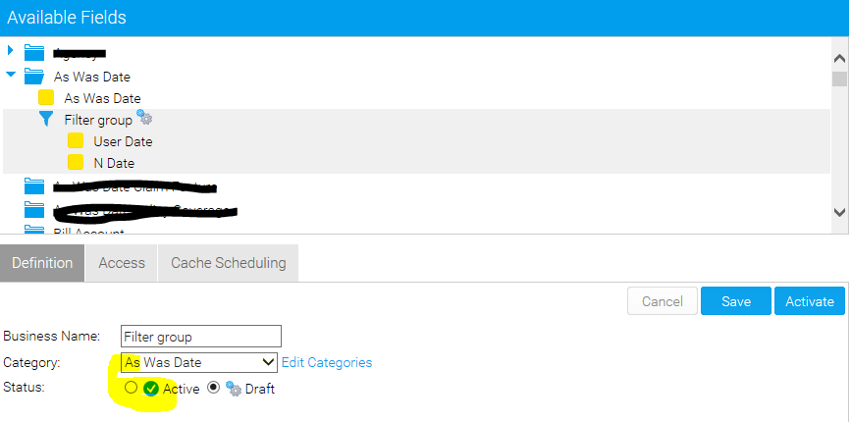

Activate
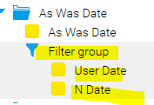

Save View and our view is ready for reporting….
Create Report
Filter Group as Filter

Filter Group looks like
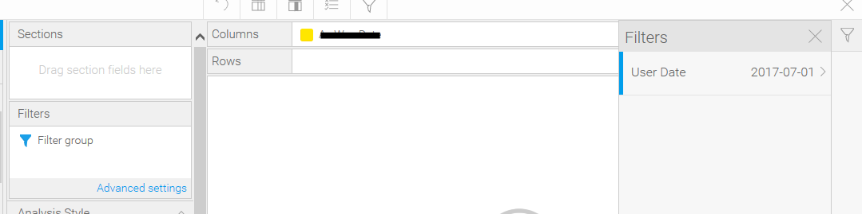

Select date and run report
Getting result with limited rows
Below is SQL Query
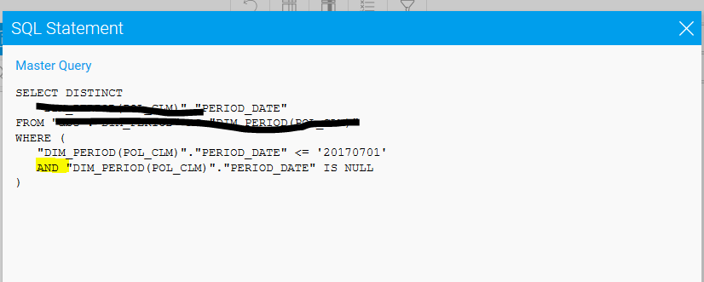

QUERY : for reporting purpose I want “OR”
Below is the sample
WHERE (
"DIM_PERIOD(POL_CLM)"."PERIOD_DATE" < = '20170727'
OR "DIM_PERIOD(POL_CLM)"."PERIOD_DATE" IS NULL
)

