Here is a report with aggregate by Fiscal Year
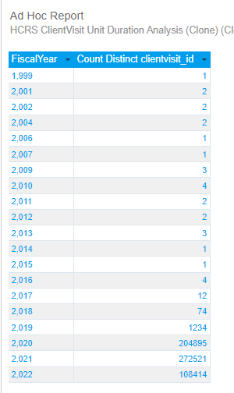
If I filter for Fiscal Year… Looks Great. Exactly What I want.
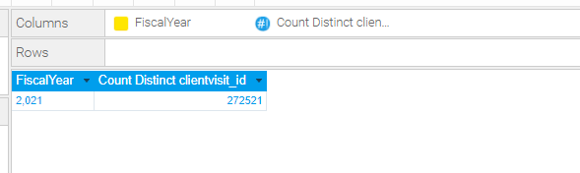
BUT if I then drill down, the MONTHS are sorted by calendar year it looks like calendar Year and there is no option to choose “Data Order” as the sort. 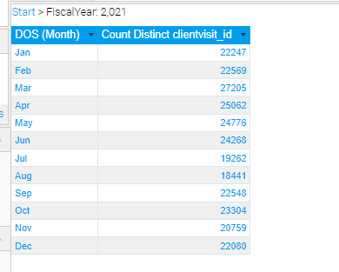
Drill down to the actual Date/Time of the visit shows that the years of the month correspond to the Fiscal Years(here I just removed the aggregation and added the date timestamp of the visit.)
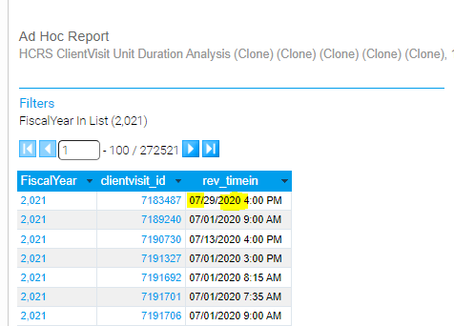

….
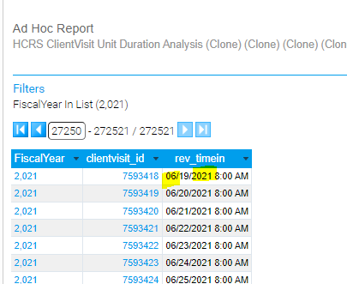
If I Add just the “YEAR” field, it doesn’t give me the sum total of the Fiscal Year but the aggregate by Calendar Year
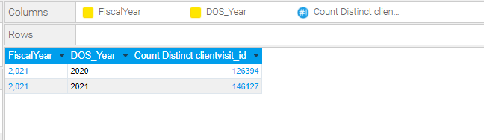
Even if I swap it:
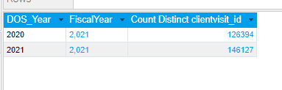
Although when drilling down, it does, give the correct month order, I really want the (above) SUM total by Fiscal Year…. (as shown in the original screen shots).

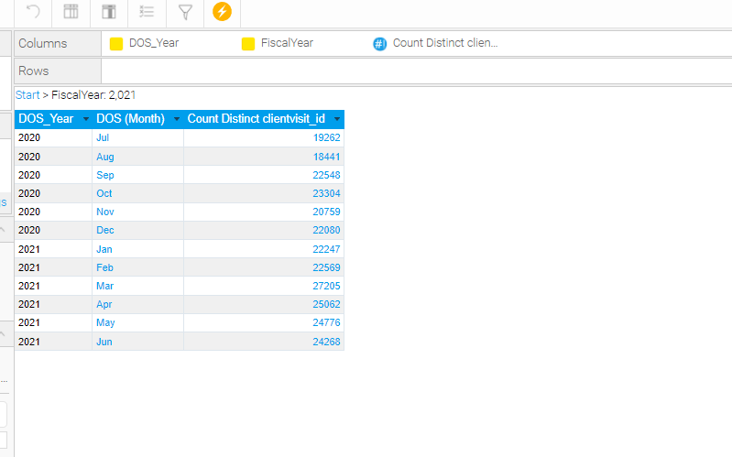

Example of the Base report is FY by Agency with Drill downs:
Agency > Division > Program > Service
Fiscal Year > Month> Day (or could be Fiscal Year > Quarter > Month
Agency | Fiscal Year | 2020 | 2021
Agency | # Unique Clients | ### | ###

Our Fiscal (Financial) Year 2020 is 01 Jul 2019 through 30 Jun 2020, but without the year, it just looks like a calendar year (Blue are months in 2020, Highlighted in Yellow are months in 2019.
After Drill down, below is a version sorted by “Data Order”
Agency | DOS (Month) | Jan | Feb | Mar | Apr | May | Jun | Sep | Oct | Nov | Dec
Agency | # Unique Clients | ### | ### | ### | ### | ### | ### | ### | ### | ### | ###
Without the data sort, it comes out alphabetical
Agency | DOS (Month) | Apr | Dec | Feb | Jan | Jun | Mar | May | Nov | Oct | Sep
Adult | # Unique Clients | ### | ### | ### | ### | ### | ### | ### | ### | ### | ###
If you add the YEAR as a separate field and sort by data order
 | Fiscal Year | 2019 |  |  |  | 2020
Divisions | DOS (Month) | Sep | Oct | Nov | Dec | Jan | Feb | Mar | Apr | May | Jun
Adult | # Unique Clients | ### | ### | ### | ### | ### | ### | ### | ### | ### | ###

I had to concatenate the YEAR to the numeric month in order for it to work:

The view has a virtual table:
select clientvisit_id
, convert(date, rev_timein) as DtRevTimein
, DatePart(Year, rev_timein) as DOS_Year
, DatePart(Month, rev_timein) as DOS_Month
, DatePart(Day, rev_timein) as DOS_Day
, YEAR(DATEADD(month, 6, clientvisit.rev_timein)) as DOS_FiscalYear
, convert(varchar, right(DatePart(Year, rev_timein),2)) + ' '
+ Case when len(DatePart(Month, rev_timein)) < 2 THEN convert(varchar, '0')+ convert(varchar, DatePart(Month, rev_timein)) Else convert(varchar, DatePart(Month, rev_timein)) END
+ '('
+ convert(varchar, left(DATENAME(MONTH, rev_timein), 3))+')' AS DOS_MM_YYYY
from ClientVisit

In the below, DOS_MM_YY Format Display Name is DOS_CY_Month
