Incident Analysis by Support Hierarchy (Copy)
Bar chart with pre-configured drill down showing current status of incidents (Open/Closed). Top Level - Assigned Support Company, Next Level - Assigned Support Organization, Next Level - Assigned Group, Final Level - Assignee.
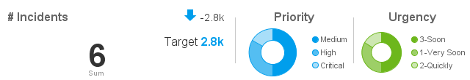
Number of Incidents | Assigned |  |  | Closed | In Progress
 | Critical | High | Medium | Medium | High
Assignee Support Company | 1-Very Soon | 2-Quickly | 3-Soon | 3-Soon | 1-Very Soon
Calbro Services | 1 | 1 | 1 | 2 | 1

